Licensing authorities’ approach to the Equality Act 2010 provisions on taxi wheelchair discrimination

Doug Paulley, July 2017

**https://www.kingqueen.org.uk/s167**

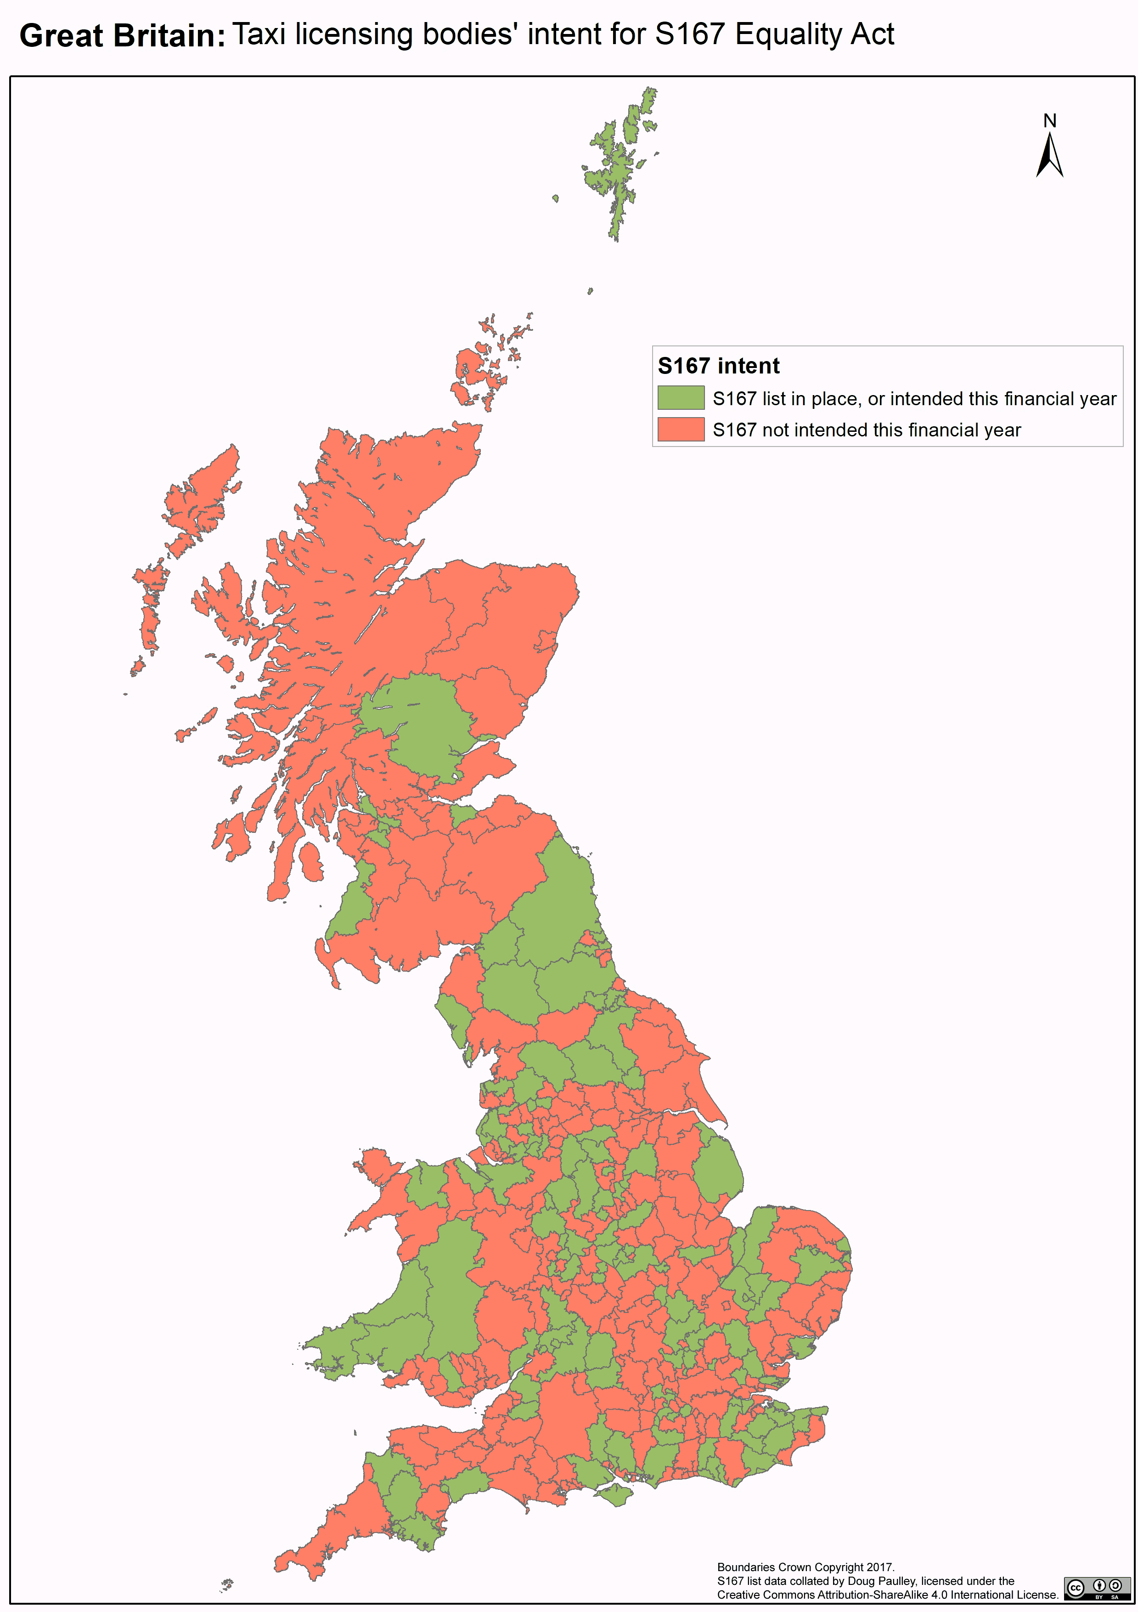

# Abstract

Wheelchair accessible taxis and private hire vehicles are important for disabled people’s lives. Section 165 of the Equality Act 2010 makes it illegal for taxi drivers to discriminate against wheelchair users. It was commenced in April 2017 but only takes effect in areas in which the taxi licensing authority has created a “designated list” of accessible vehicles under S167 of the act. However local authorities aren’t obliged to create such a list.

I decided to investigate whether licensing authorities intend to create such a list. I did so by means of Freedom of Information requests to every authority. The results show that only 41% of authorities have current clear plans to create a list. 26% of authorities have actively decided not to work towards such a list at the moment, despite specific and strident statutory guidance exhorting them to do so.

Licensing bodies’ failure to create S167 lists constitutes a substantial barrier to disabled people’s transport rights, and undermines the intent behind these provisions of the Act. However, education, campaigning and publicity have been effective in changing some authorities’ unhelpful attitude to these provisions. More widespread use of such pressure may improve compliance, or may spark corrective primary legislation.

Contents

1. Abstract 1

3. Introduction 4

a) Legislative background 4

b) S167 lists 4

c) The issue in question 5

d) Subsidiary issues 5

Voluntary lists 5

Enforcement 5

Exemptions 6

Definition of Wheelchair Accessible Vehicle 6

4. Methods 7

a) Identifying Licensing Bodies 7

b) Freedom of Information (FOI) Requests 7

c) Characteristics of licensing authorities 8

Data for England, Scotland and Wales 8

Data for England and Wales only 8

Data for England only 8

d) Classification of Authorities’ Responses 8

S167 grade 8

Rural: Urban categorisation 9

e) Analysis 9

5. Results 10

a) Accompanying spreadsheet 10

b) S167 intent 10

Overall 10

S167 intent by Country 12

c) S167 Grade 13

d) Rural: Urban category and S167 intent 16

e) Variation in provision of wheelchair accessible taxis 19

f) Enforcement mechanisms 23

g) Medical exemptions 23

h) Voluntary Lists 24

i) Disability Awareness Training 25

j) Authorities where some or all licenses are solely for accessible taxis 25

k) Qualitative observations 26

Lack of knowledge or understanding of S165-S167 26

Authorities with 100% wheelchair accessible taxis generally don’t produce S167 lists 26

“Insufficient” accessible taxis 26

Disagreement with the Department for Transport’s guidance 26

6. Discussion 27

a) Importance of Taxis 27

b) S167 take-up 27

c) Ignorance 27

d) Enforced education 27

e) Areas with poor provision 28

f) Unclear guidance 28

g) Inconsistent enforcement 29

h) Inadequacy of Guidance 29

i) Remedies 30

7. Conclusion 31

8. Recommendations 32

a) To the Department for Transport 32

b) To Local Authorities and TFL 32

c) To disabled people, disabled people’s organisations and allies 32

9. Appendices 33

Appendix 1 – Freedom of Information request sent to each authority 33

Appendix 2 – Sample Internal Review request 34

Appendix 3 - Rural: Urban Classification Maps 35

Appendix 4: Acknowledgements 37

Appendix 5: Licensing 37

Appendix 6: Lists of Tables, Figures and Maps 38

Tables 38

Figures 38

Maps 38

Appendix 7: References 39

# Introduction

## Legislative background

This research is to examine whether taxi licensing authorities intend to employ the powers afforded to them under sections 165 and 167 of the Equality Act (the Act), to make it illegal for taxi and private hire drivers to discriminate against wheelchair users.

S165 of the Act places legal obligations on drivers of wheelchair accessible taxis and private hire vehicles (PHVs) to not discriminate against wheelchair users. Specifically, they are obliged:

1. to carry the passenger while in the wheelchair;
2. not to make any additional charge for doing so;
3. if the passenger chooses to sit in a passenger seat, to carry the wheelchair;
4. to take such steps as are necessary to ensure that the passenger is carried in safety and reasonable comfort; and
5. to give the passenger such mobility assistance as is reasonably required[1]

This is a new duty. It’s been on the statute books since 1995, but was only commenced on 6th April 2017, in the wake of pointed criticism by the Equality Act 2010 and Disability select committee.[2] The Government stated:

Having given careful consideration to the effects of commencing sections 165 and 167 of the Equality Act, including ensuring that drivers understand fully their responsibilities, we will now proceed to bring the measures into force, aiming for commencement by the end of 2016. This will provide wheelchair users with similar protection from discrimination as that already available to assistance dog owners – ensuring that they are provided with the assistance they need to access taxis and private hire vehicles, and that they can no longer be charged extra.

## S167 lists

The legislation, however, has an Achilles heel: it only takes effect in areas of the country where taxi and PHV licensing authorities have created a specific list of wheelchair accessible vehicles under s167 of the Act.

In February 2017, the Department for Transport issued statutory guidance to taxi licensing authorities[3], which states:

Section 167 of the Act permits, but does not require, LAs (Local Authorities) to maintain a designated list of wheelchair accessible taxis and PHVs.

Whilst LAs are under no specific legal obligation to maintain a list under section 167, the Government recommends strongly that they do so. Without such a list the requirements of section 165 of the Act do not apply, and drivers may continue to refuse the carriage of wheelchair users, fail to provide them with assistance, or to charge them extra.

The guidance recommends licensing authorities work towards producing a S167 list by October 2017.

## The issue in question

To the best of my knowledge, at the time of writing (April to July 2017) nobody is evaluating whether taxi and PHV licensing authorities intend to use their power to create a S167 list.

My intent in this research is to ascertain whether authorities are going to create S167 lists, or are not.

## Subsidiary issues

### Voluntary lists

On 15th September 2010, the Department for Transport issued guidance on the Act which stated, in relation to section 167:

although the list of designated vehicles will have no actual effect in law until the duties are commenced, we would urge licensing authorities to start maintaining a list as soon as possible for the purpose of liaising with the trade and issuing exemption certificates.

I term such lists as “voluntary lists”. A licensing authority’s take-up of the recommendation to produce such could be an indicator of an authority’s intent to produce a S167 list. I therefore examined the extent of taxi licensing authorities’ take-up of this recommendation.

### Enforcement

Analogous regulations[4] place bus drivers under obligations to wheelchair users:

If there is an unoccupied wheelchair space on the vehicle, a driver and a conductor shall allow a wheelchair user to board…

A driver and a conductor shall ensure … that wheelchair users can gain access into and can get out of a wheelchair space … before the vehicle is driven, that any wheelchair user is correctly and safely positioned in a wheelchair space …

Where a wheelchair user wishes to board or to alight from a Schedule 1 vehicle and requests assistance to do so, a driver and a conductor shall provide assistance to him.

Extensive experience, direct and vicarious, makes clear that breaches of the bus regulations are commonplace. However, the Department for Transport has stated:[5]

Since the Department is not aware that any legal action has been taken under the Regulations, although we cannot be certain, the probability is that there has been no such action.

I worry that similar may occur with the taxi anti-discrimination provisions of the Act. There seems little point in legislation that is not enforced. I therefore included authorities’ intended enforcement mechanisms in my research.

### Exemptions

Section 166 of the Acti requires authorities to grant exemptions to drivers of wheelchair accessible taxis or private hire vehicles from their obligations to wheelchair users. Such exemptions may be granted:

on medical grounds, or

on the ground that the person's physical condition makes it impossible or unreasonably difficult for the person to comply with those duties.

Section 166 was commenced in 2010, so authorities have been able issue such exemptions since then. This is a somewhat perverse situation, as stated by the Equality Act 2010 and Disability Select Committee:[6]

taxi drivers can apply for exemption from duties which do not apply and which, since their enactment 20 years ago, have never applied

The number of exemptions granted by a licensing authority could be an indication of the resolution or zeal of the licensing authority, or to whether exemptions may seriously undermine wheelchair users’ rights. I therefore included authorities’ issuing of such exemptions as part of my research.

### Definition of Wheelchair Accessible Vehicle

The Act leaves local authorities to make their own definition as to what qualifies as a “wheelchair accessible vehicle” for inclusion in a S167 list. Whilst I initially intended to examine this issue, I eventually decided to declare this issue “out of scope” for my research due to the amount of extra time, work and headspace investigating such would engender.

# Methods

## Identifying Licensing Bodies

Sections 165 to 167 of the Equality Act have effect in Great Britain (but not Northern Ireland). There are 367 taxi and private hire licensing bodies in England, Scotland and Wales; comprising Transport for London (covering all local authorities in Greater London) and county, borough or unitary councils throughout the rest of the countries.

I used the list of licensing authorities in England and Wales provided in the Department for Transport’s 2015 Taxi and Private Hire Vehicles statistics,[7] and the list of licensing authorities in Scotland from Transport Scotland’s datasets.[8]

## Freedom of Information (FOI) Requests

On 19th April 2017, I sent the same Freedom of Information request to all 367 licensing authorities (see Appendix 1 – Freedom of Information request sent to each licensing authority.) I did so via WhatDoTheyKnow.com, to assist with keeping track of the requests and to ensure that all responses are published online for any interested party to read.

I collated the responses, and acted where required to pressurise authorities into providing the information. Actions required included:

* Chasing authorities that failed to respond
* Engaging assistance from the Information Commissioner’s Office and the Scottish Information Commissioner to chase responses from authorities that still failed to respond
* Asking for clarification of responses
* Requesting Internal Reviews of authorities’ responses
* Obliging the Information Commissioner to conduct assessments of authorities’ handling of my FOI requests.

This process involved sending and receiving thousands of emails over three months.

Whilst public authorities are obliged by the Freedom of Information Act 2000 to respond to Freedom of Information Requests with the information required or a valid exemption “*promptly and in any event not later than the twentieth working day following the date of receipt,*”[9] it is common experience that authorities’ compliance with the Act is variable at best.

As of writing, 334 of the 347 authorities have responded with all the information I requested. The remaining 13 supplied partial information, even after internal review. I am awaiting the Information Commissioner’s intervention in the 13, following my complaints.

All 347 authorities have stated whether they have a current S167 list. 10 have yet to respond to the element of my request asking whether they intend to create such a list.

The “success rate” of my 367 FOI requests is therefore over 97%.

## Characteristics of licensing authorities

The datasets from the Department for Transport and from Transport Scotland include the following data, or data from which the following can be derived. This data may be of interest when identifying characteristics of licensing authorities and their approach to S167 lists. I therefore incorporated this data in my analysis of the FOI responses.

### Data for England, Scotland and Wales

* The number of accessible taxis licensed by each authority
* The proportion of taxis licensed by the authority that are wheelchair accessible
* The number of wheelchair accessible taxis per thousand population in the licensing authority’s area

### Data for England and Wales only

* Whether the licensing authority requires some or all licensed taxis to be wheelchair accessible
* Whether the licensing authority obliges taxi drivers to undertake disability awareness training

### Data for England only

* The Rural: Urban classification of each authority[10]. See Appendix 3 - Rural: Urban Classification Maps

## Classification of Authorities’ Responses

To ease analysis, I classified each authority’s approach to S167 as revealed by my FOI request using the following rubric.

### S167 grade

|  |  |
| --- | --- |
| **A** | **Authority has a valid S167 list** |
| **B** | **Authority intends to produce a S167 list this financial year** |
| **C** | **Authority intends to produce S167 list but has no clear deadline** |
| **D** | **Authority currently undecided whether to produce a S167 list** |
| **E** | **Authority has no current plans to produce a S167 list** |

Table 1 - S167 grade

This process is inevitably subjective. Whilst some authorities’ responses were clear, others were less so. For instance, Transport for London believe the following phrase meets the criteria set out in S167 and so that they have a S167 list:

All taxis in London are wheelchair-accessible and have been designated as such under Section 167 of the Equality Act 2010.[11]

I, however, don’t accept that this complies with the Department for Transport’s statutory guidance, and have therefore classified them as not having a S167 list.

Similar judgments were required when classifying other authorities’ responses.

For a coarse binary indication of authorities’ approach to S167, I split councils as follows:

**S167 intent**

|  |  |  |
| --- | --- | --- |
| **Yes** | **Authority has a current S167 list, or intends to produce one this financial year**  **(S167 grades A or B)** | |
| **No** | **Authority hasn’t set a date for producing a S167 list, has yet to decide whether to produce one or has no current plans to do so (S167 grades C, D or E)** |  |

Table 2 – S167 intent

It was debatable where to put the dividing line. I chose to include authorities that have indicated a clear deadline by which they intended to produce a S167 list, and to not include authorities that gave no such clear deadline.

I did so as I consider that authorities which indicated an intent to create their lists by a specific date are more likely to do so than those that were less clear. This is an imperfect and subjective decision; doubtless many authorities who have not indicated a deadline will produce their list within a year.

### Rural: Urban categorisation

I further divided English authorities into crude Urban and Rural categories:

|  |  |
| --- | --- |
| Rural | Urban |
| Largely Rural  Mainly Rural  Urban with Significant Rural | Urban with Minor Conurbation  Urban with City and Town  Urban with Major Conurbation |

Table 3 – Rural: Urban categorisation

Transport for London’s area isn’t classified in the Department for Transport data tables, so for the purposes of my research, I classified it as “Urban with Major Conurbation”.

## Analysis

I then undertook statistical analysis of the data collected via Freedom of Information requests, together with the data provided by the Department for Transport and by Transport Scotland, to identify common trends.

# Results

## Accompanying spreadsheet

The data tables, statistical analysis, charts and maps are available in the [accompanying spreadsheet](https://www.kingqueen.org.uk/s167)[12].

As I state above, at the time of writing over 97% of authorities had responded to my FOI request in full. The remaining 3% have supplied some data, but I am awaiting the assistance of the Information Commissioner to extract the remainder.

As the remaining data comes in, I shall update the accompanying spreadsheet, but not this report. For the full and up to date results, data and calculations, please examine the spreadsheet.

## S167 intent

### Overall

Figure 1 –GB S167 intent

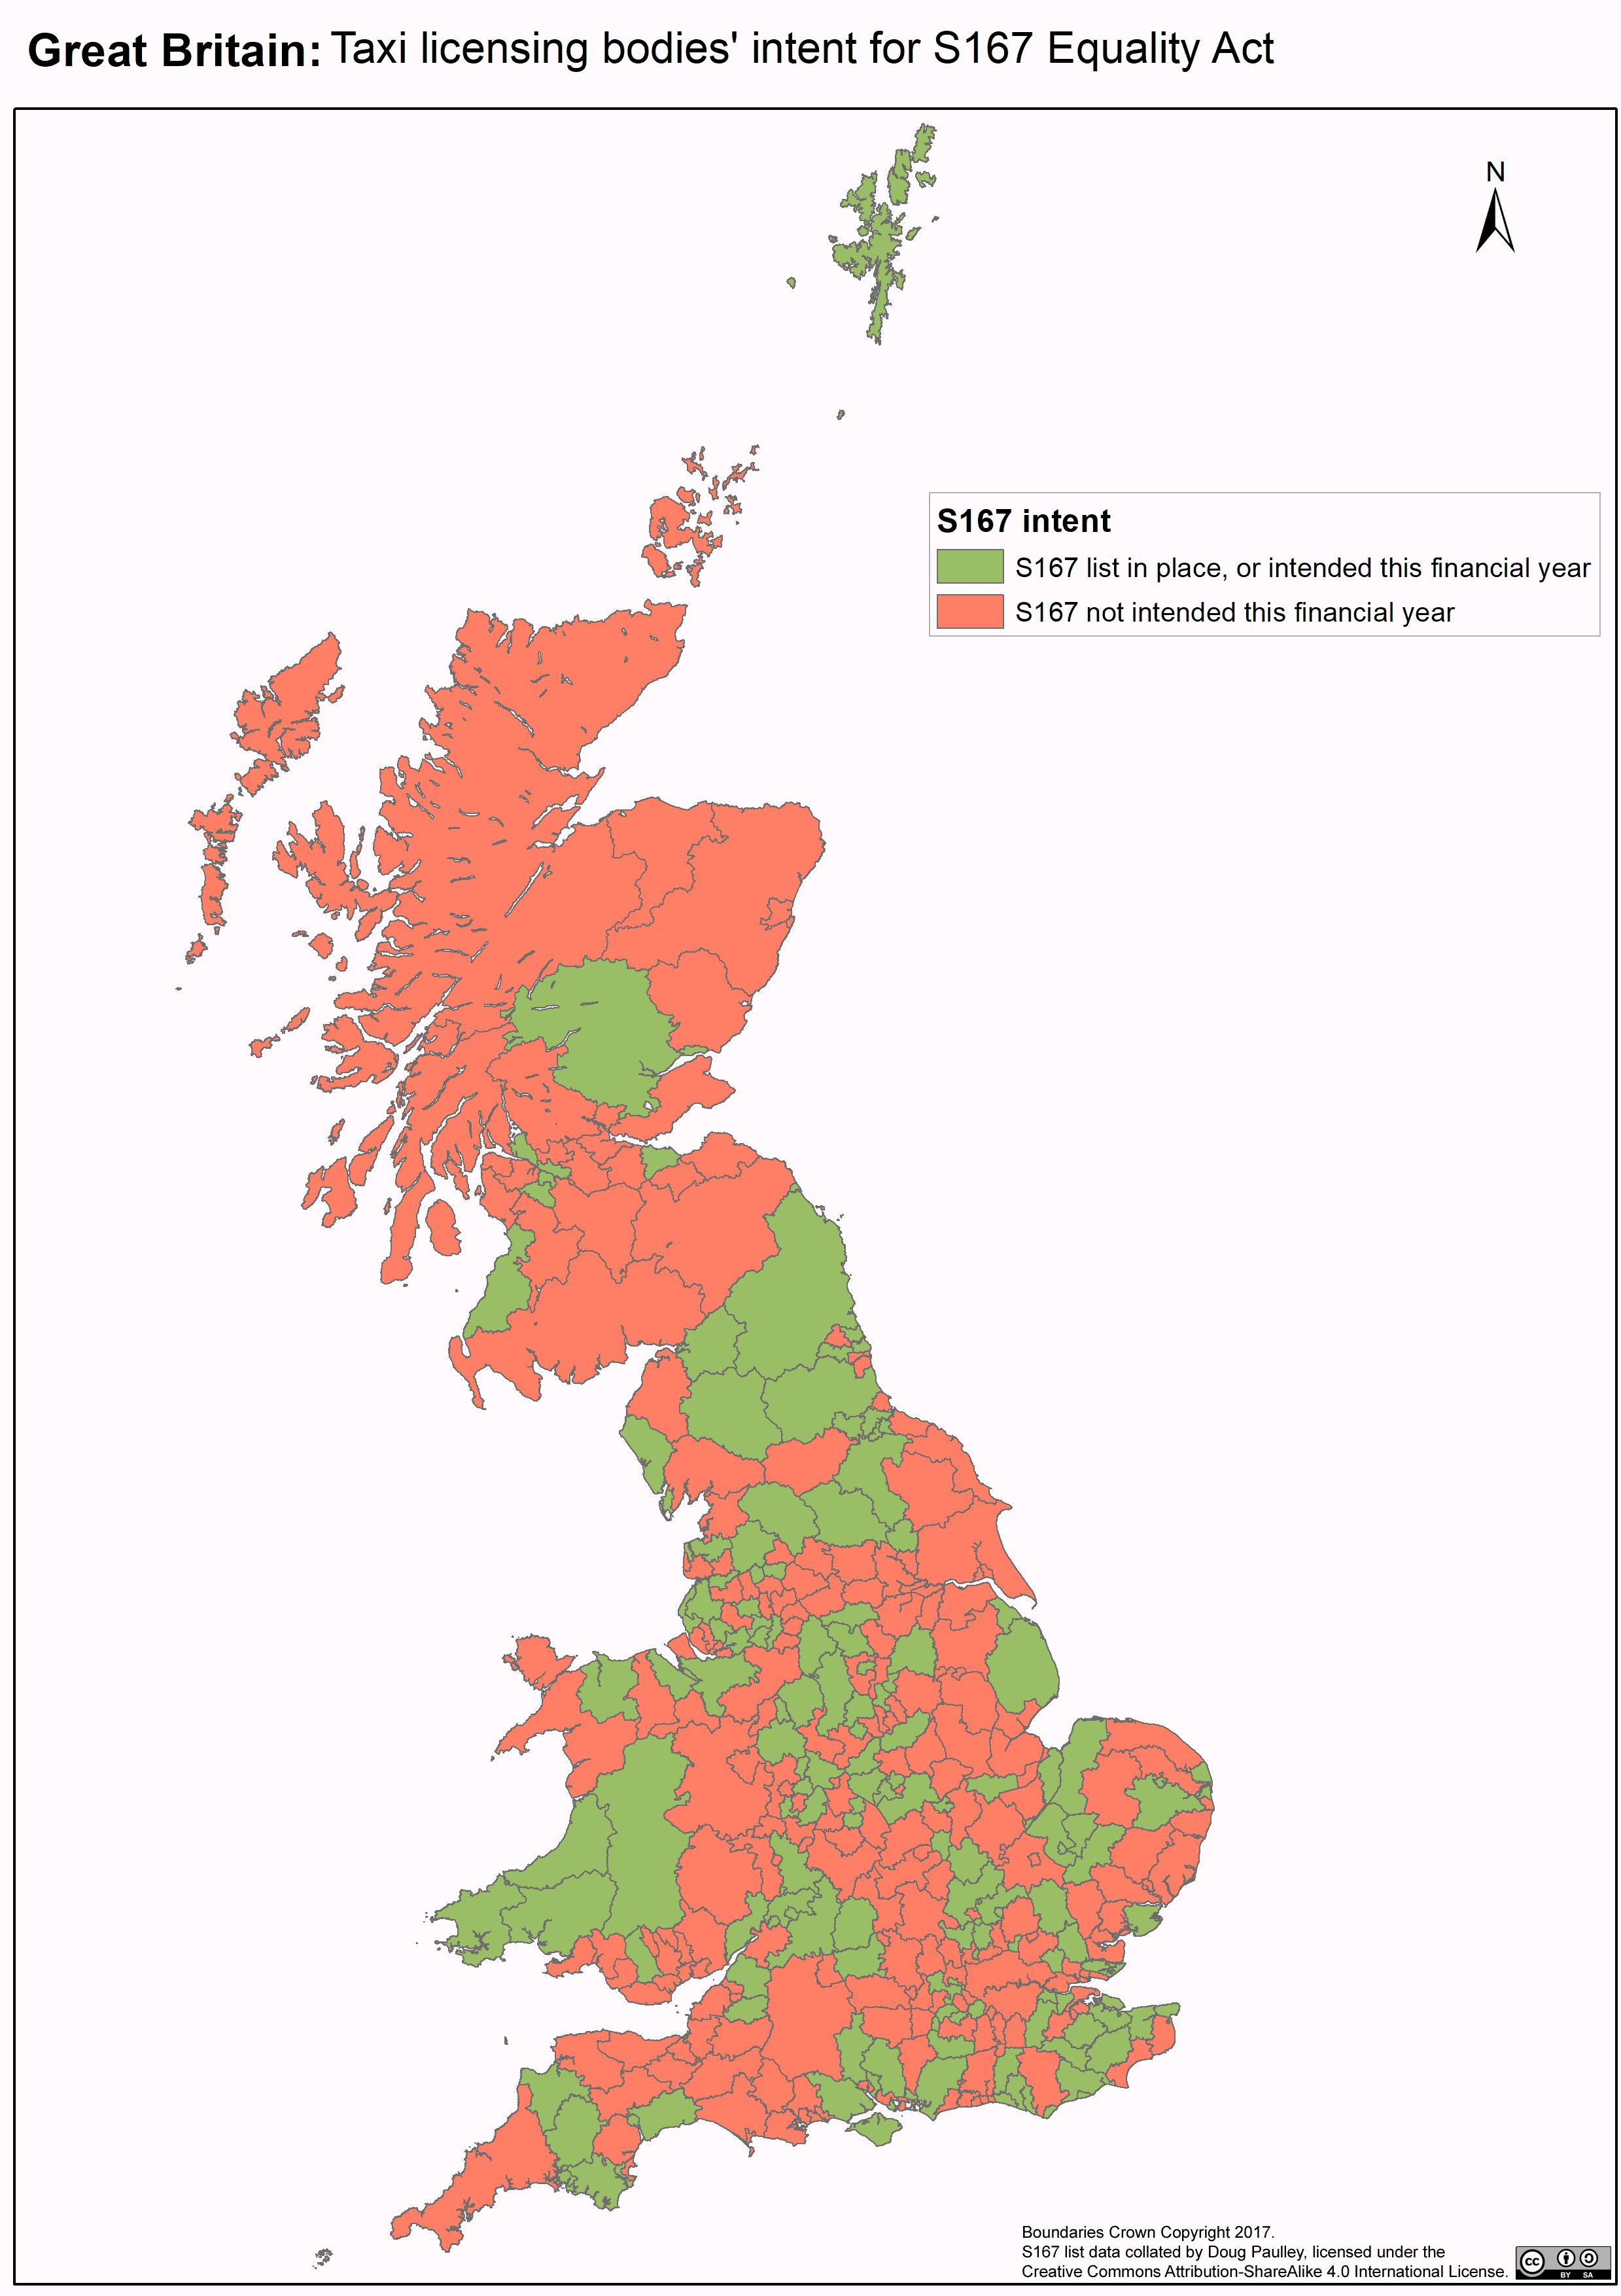

Map 1 - Map of S167 intent

|  |  |  |
| --- | --- | --- |
| **S167 intent** | **# Authorities** | **% Authorities** |
| **Yes** | **143** | **41%** |
| **No** | **204** | **59%** |

Table 4 - GB S167 Intent

|  |  |
| --- | --- |
| **Yes** | **have a S167 list or intend one within this financial year** |
| **No** | **yet to decide / decided not to / not set a date.** |

Somewhat under half of authorities currently either have an S167 list or intend to create one by the end of the financial year.

Authorities’ approach to S167, and to taxi accessibility in general, varies considerably.

At one end of the spectrum, authorities such as Sheffield City Council have had a “voluntary” list for decades. All their licensed taxis are wheelchair accessible, they require drivers to undertake disability awareness training, and they implemented s167 on the day it was commenced.

At the other extreme are authorities such as Spelthorne, who despite being “urban with a major conurbation” have no intent to implement S167, no voluntary list, and have only two accessible taxis throughout their area.

### S167 intent by Country

Figure 2 – Constituent countries S167 intent

|  |  |  |  |  |  |  |
| --- | --- | --- | --- | --- | --- | --- |
| **S167 intent** | **English Authorities** | **% English Authorities** | **Scottish Authorities** | **% Scottish Authorities** | **Welsh Authorities** | **% Welsh Authorities** |
| Yes | 128 | 44% | 8 | 25% | 7 | 32% |
| No | 165 | 56% | 24 | 75% | 15 | 68% |
| **Total** | **293** | **100%** | **32** | **100%** | **22** | **100%** |

Table 5 – Constituent countries S167 intent

It is apparent that Scottish authorities (and to a lesser extent Welsh authorities) have a distinctly lower rate of intended take up of S167 compared to English authorities.

## S167 Grade

|  |  |  |  |
| --- | --- | --- | --- |
|  |  |  |  |
|  | **LEGEND:** |  |  |
|  |  |  |  |
|  | **A** | **Current S167 list** |  |
|  | **B** | **Producing S167 list this financial year** |  |
|  | **C** | **Producing S167 list but no clear deadline** |  |
|  | **D** | **Undecided whether producing S167 list** |  |
|  | **E** | **No current plans to produce S167 list** |  |
|  |  |  |  |

Figure 3 – GB S167 grades

|  |  |  |
| --- | --- | --- |
| **S167 status** | **# Authorities** | **% Authorities** |
| **A** | 38 | 11% |
| **B** | 105 | 30% |
| **C** | 53 | 15% |
| **D** | 62 | 18% |
| **E** | 89 | 26% |
| **Total** | **347** | **100%** |

Table 6 – GB S167 grades

It is perhaps unsurprising that a substantial proportion of authorities intend to create a list this financial year, in accordance with the DFT’s guidance. Of concern are the 18% who have yet to decide whether to create a list, and the 26% who have no current plans to do so.

|  |  |  |  |  |  |  |
| --- | --- | --- | --- | --- | --- | --- |
| **S167 grade** | **English authorities** | **% English authorities** | **Scottish authorities** | **% Scottish authorities** | **Welsh authorities** | **% Welsh authorities** |
| **A** | **33** | **11%** | **1** | **3%** | **4** | **18%** |
| **B** | **95** | **32%** | **7** | **22%** | **3** | **14%** |
| **C** | **41** | **14%** | **6** | **19%** | **6** | **27%** |
| **D** | **48** | **16%** | **10** | **31%** | **4** | **18%** |
| **E** | **76** | **26%** | **8** | **25%** | **5** | **23%** |
| **Total** | **293** | **100%** | **32** | **100%** | **22** | **100%** |

Figure 4 – Constituent countries S167 grades

Table 7 – Constituent countries S167 grades

The proportion of bodies that have no current intent to implement S167 seems uniform across Great Britain. The most significant variation appears to be amongst bodies that have yet to decide whether to implement S167. Scottish authorities are disproportionately indecisive.

A greater proportion of English and Welsh authorities than Scottish ones have already implemented S167.

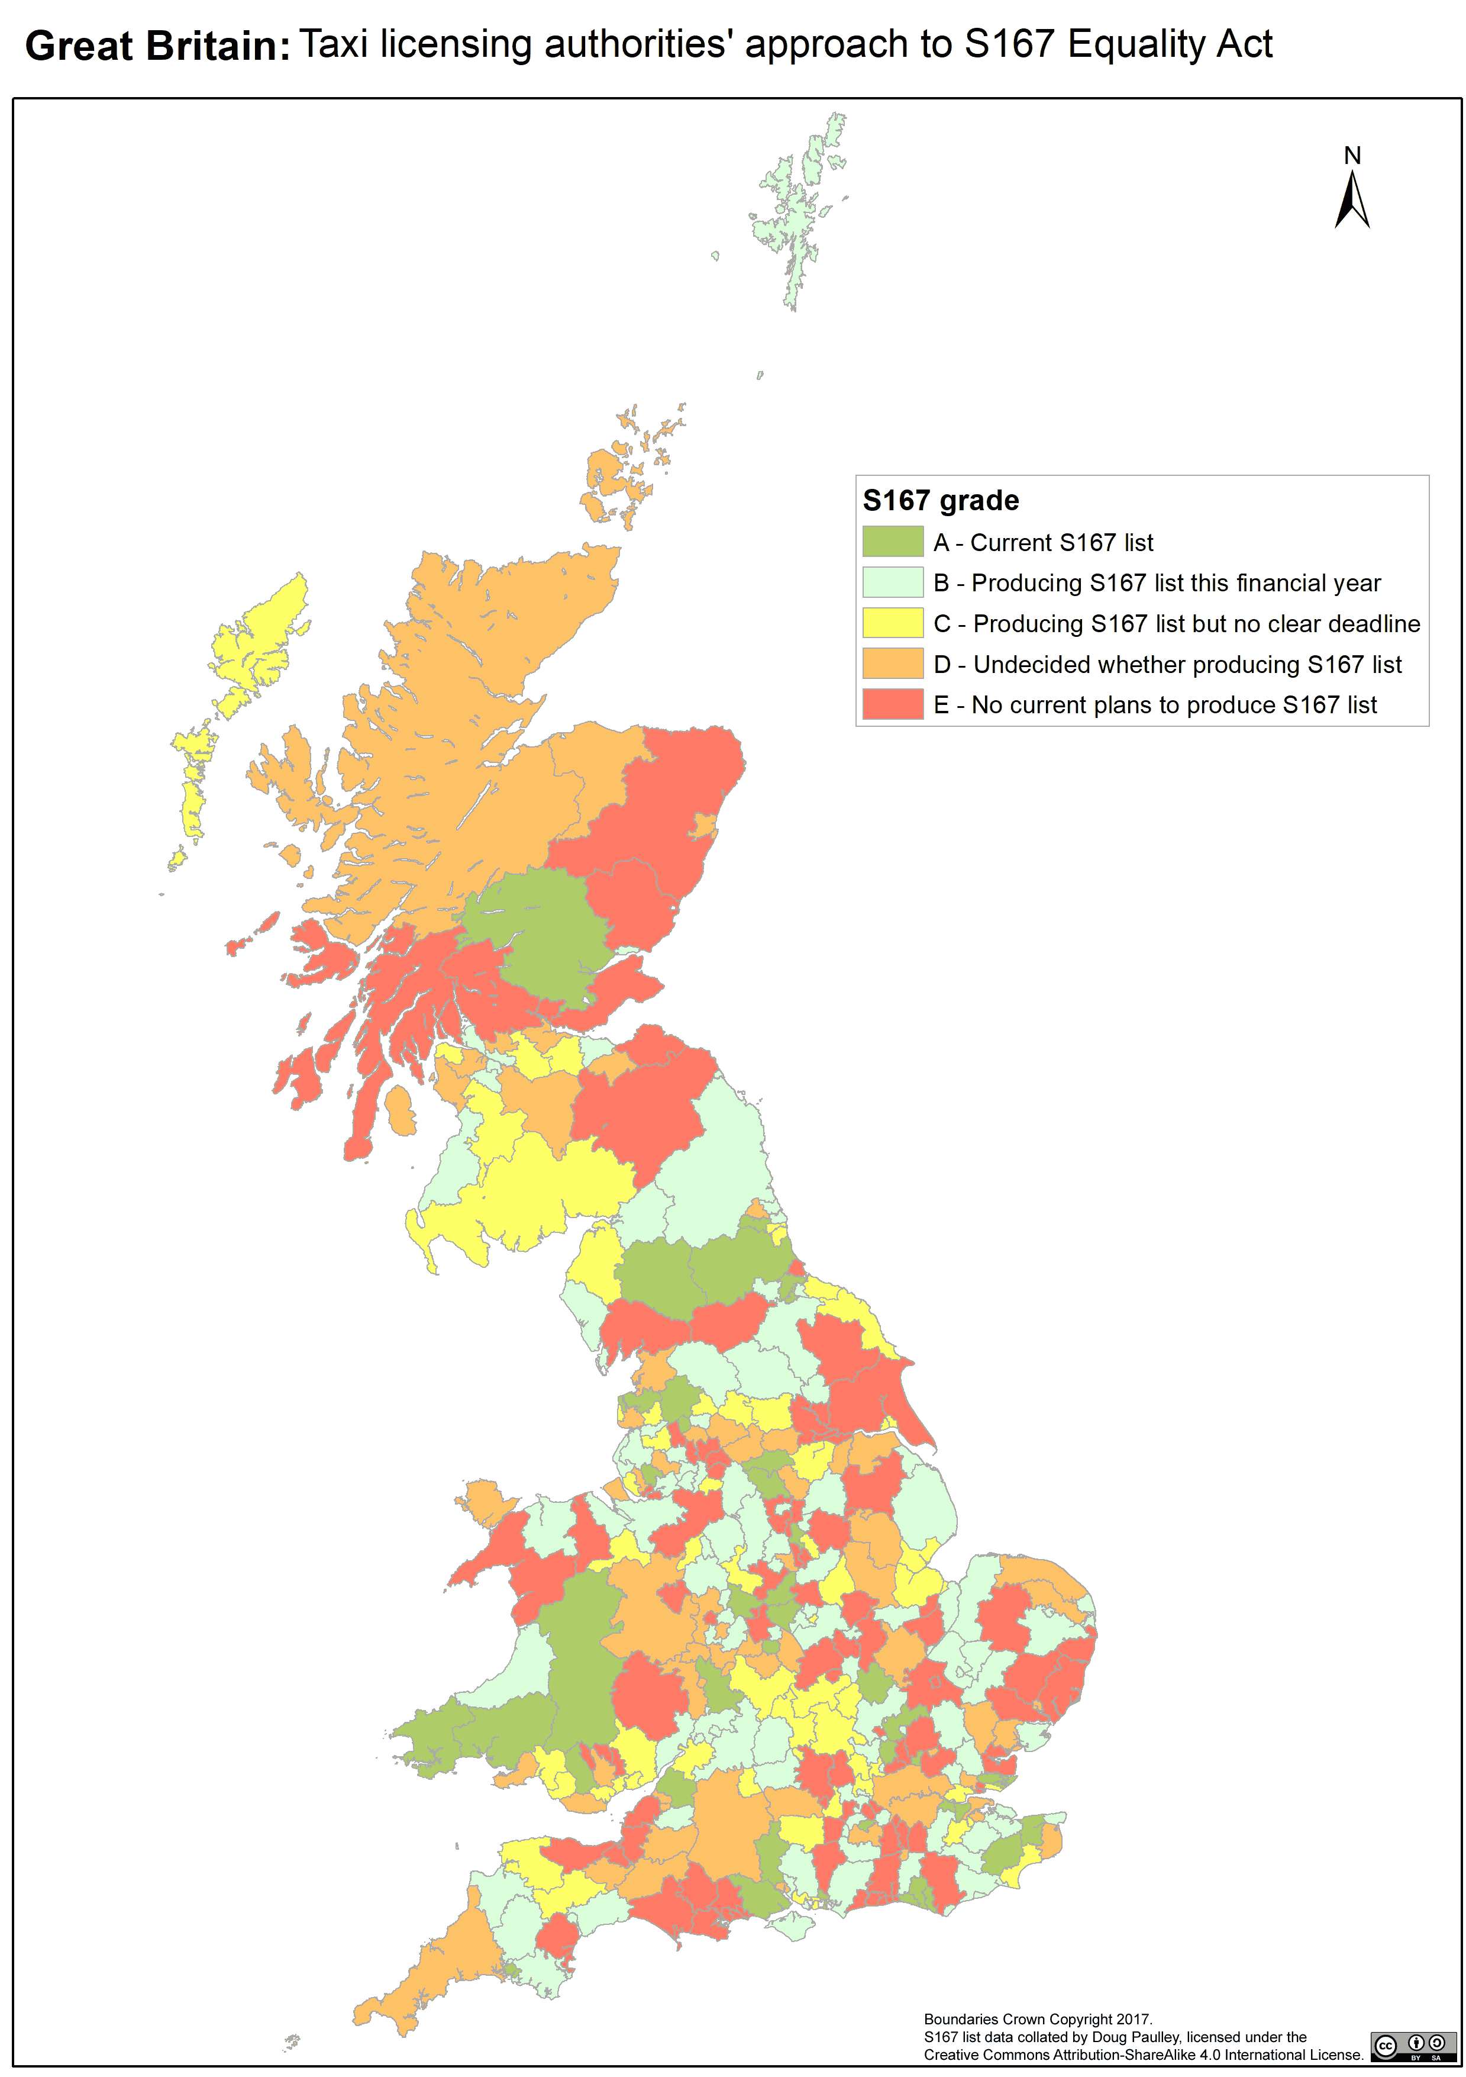

Map 2 – S167 grades

## Rural: Urban category and S167 intent

There is little difference between authorities’ S167 intent on a binary Rural: Urban basis:

|  |  |  |  |
| --- | --- | --- | --- |
|  | **s167 intent** | |  |
| **Rural:Urban** | **Yes** | **No** | **Total** |
| **Rural** | **44%** | **56%** | **100%** |
| **Urban** | **44%** | **56%** | **100%** |
| **Average** | **44%** | **56%** | **100%** |

Table 8 – Rural: Urban S167 Intent

This surprised me; I had assumed that urban councils would be more likely to intend to create a S167 list than rural ones. However, more variation is apparent when considering more granular rural: urban categories.

|  |  |  |  |
| --- | --- | --- | --- |
|  | **S167 intent** | |  |
| **Rural: Urban Category** | **Yes** | **No** | **Total** |
| **Largely Rural** | **54%** | **46%** | **100%** |
| **Mainly Rural** | **41%** | **59%** | **100%** |
| **Urban with Significant Rural** | **39%** | **61%** | **100%** |
| **Urban with Minor Conurbation** | **33%** | **67%** | **100%** |
| **Urban with City and Town** | **45%** | **55%** | **100%** |
| **Urban with Major Conurbation** | **42%** | **58%** | **100%** |
| **Average** | **44%** | **56%** | **100%** |

Table 9 – Rural Urban Classification S167 Intent

Figure 5 – Rural Urban Classification S167 Intent

Figure 6 – Rural Urban Classification S167 Grade

“Mainly Rural” areas are least likely to intend to create a S167 list. They also have the lowest proportion of authorities who have already made a S167 list.

The areas with the highest take-up of S167 are “urban with a minor conurbation.” “Largely rural” areas are the most likely to intend to create a S167 list.

There is no clear relationship between an authority’s rural: urban status and its S167 intent. This is perhaps surprising, as the proportion of accessible taxis varies considerably with the nature of the area:

Figure 7 – Wheelchair accessible taxis by Rural Urban Classification

Figure 8 – Wheelchair accessible taxis by Rural: Urban

The proportion and number of wheelchair accessible taxis is distinctly lower in rural areas than in urban areas. One wonders if this reflects the distribution of wheelchair users, and/or whether this forms an active barrier to rural-living disabled people’s transport.

## Variation in provision of wheelchair accessible taxis

There is substantial variation in the wheelchair accessible proportion of taxi fleets across the country.

|  |  |
| --- | --- |
| **Accessible Taxis** | **% Authorities** |
| 10% or less | 39% |
| 11% to 50% | 29% |
| 51% to 99% | 12% |
| 100% | 19% |
| **Total** | **100%** |

Table 10 - Wheelchair Accessible Taxis in each area

Figure 9 –Wheelchair Accessible Taxis in each area

Figure 10 – Proportion of Accessible Taxis by S167 Grade

Authorities with the highest proportion of accessible taxis, and with the largest number of wheelchair accessible taxis per 1,000 population, are more likely to be intending to create a S167 list rather than to already have a list or to have decided not to create a list.

Authorities who have stated they don’t intend to have a list have noticeably fewer accessible taxis per 1,000 population.

Over a third of authorities have very few wheelchair accessible vehicles, with less than 10% of taxis in their area being wheelchair accessible.

15 councils have no accessible taxis at all. These are: Barrow-in-Furness, Ryedale, South Derbyshire, Rutland, Staffordshire Moorlands, Broadland, East Cambridgeshire, Epping Forest, Uttlesford, South Bucks, Lewes, Wilden, Tewkesbury and Pembrokeshire.

Surprisingly, two of the councils with no accessible taxis have S167 lists in place. A further six have expressed their intent to create a list. This may be a function of time difference; the Department for Transport’s accessibility statistics were published in 2015, whereas my S167 research was conducted in 2017. Perhaps some authorities have licensed accessible taxis in the intervening years.

68 authorities have entirely wheelchair accessible fleets. However, these authorities were just as likely (or unlikely) to be intending to create a S167 list:

|  |  |  |  |  |
| --- | --- | --- | --- | --- |
|  | **Fleet Accessibility** | | | |
|  | **<100% accessible** | | **All accessible** | |
| **S167 intent** | **# Authorities** | **% Authorities** | **# Authorities** | **% Authorities** |
| Yes | **115** | **41%** | **28** | **42%** |
| No | **165** | **59%** | **39** | **58%** |
| **Total** | **280** | **100%** | **67** | **100%** |

Table 11 – S167 intent of areas with 100% and non-100% accessible taxi fleets

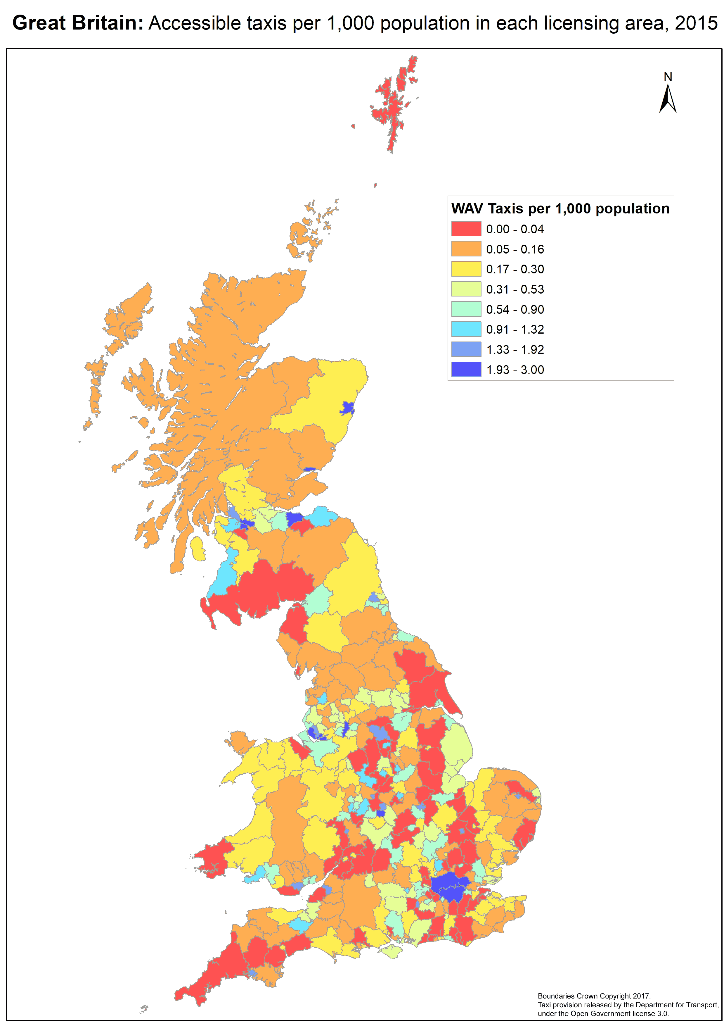

Map 3 – Accessible Taxis per 1,000 Population

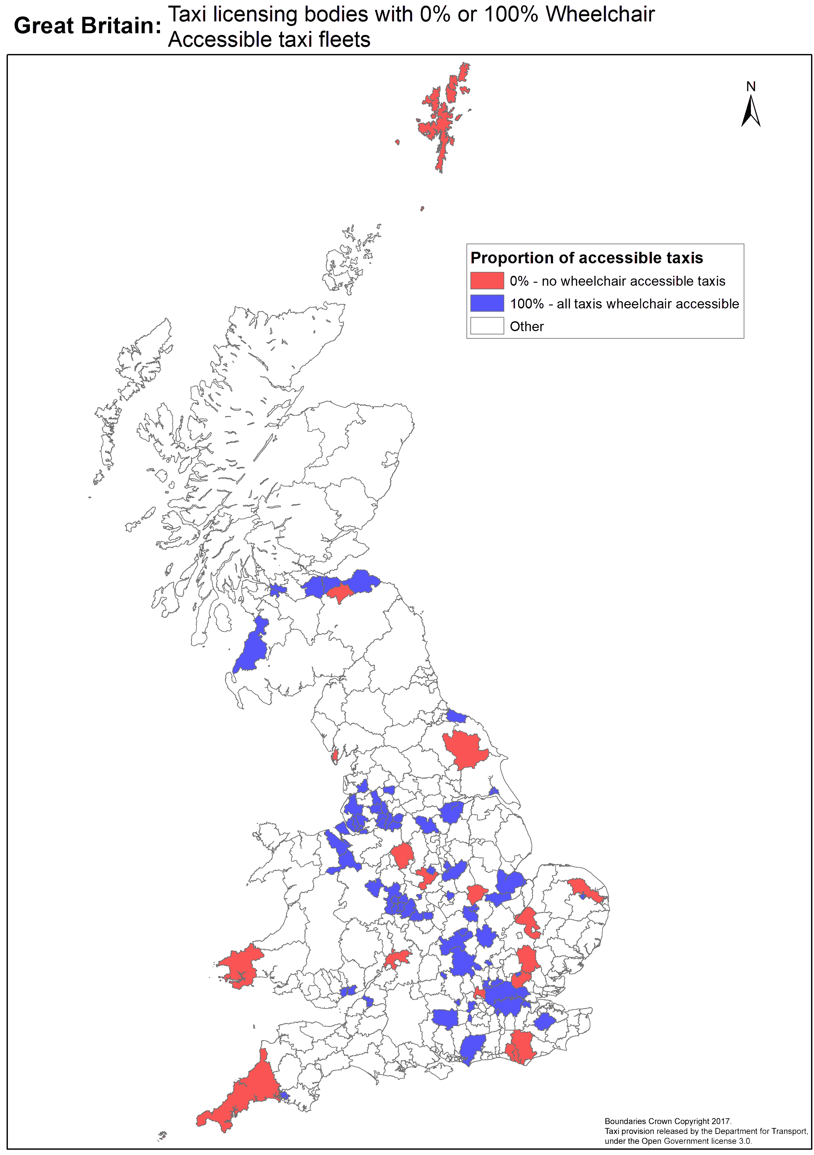

Map 4 – Areas with 0% and 100% wheelchair accessible taxi fleets

## Enforcement mechanisms

The elements of my FOI request on this topic was unstructured, so the data received is not comprehensive. The following lists numbers of authorities that proactively mentioned the relevant enforcement mechanisms.

|  |  |  |
| --- | --- | --- |
| **Mechanism** | **Authorities** | **% Authorities** |
| **Complaints** | 92 | 77% |
| **Inspections** | 36 | 30% |
| **Mystery Shopper** | 27 | 23% |
| **Other** | 27 | 23% |

Table 12 – Enforcement mechanisms

Figure 11 – Enforcement mechanisms

## Medical exemptions

Most authorities (289) had not issued any medical exemptions. A further 45 had issued 10 or less.

There are 12 councils with disproportionately large number of medical exemptions. Blackpool had the most with 89, and Plymouth had the second highest with 82. In 2015, Blackpool had 113 wheelchair accessible taxis, so unless Blackpool has an unusually high number of wheelchair accessible PHVs, most of its wheelchair accessible taxis are being driven by people who are medically exempt from the requirement to carry wheelchair users.

North East Lincolnshire is notable for over half its wheelchair accessible taxi drivers holding medical exemptions, with Taunton Deane not far behind.

Perhaps unsurprisingly, most licensing authorities with high numbers of exemptions have a requirement that some or all licensed taxis are wheelchair accessible. Blackpool does not have this requirement, however. Nor does it have any requirement that drivers undertake disability awareness training.

Only three authorities have had medical exemption applications since S167 was commenced. Coventry has had 14 such, having never had any such applications before.

## Voluntary Lists

These are the proportions of authorities that created voluntary lists of accessible taxis in compliance with the Department for Transport’s 2010 guidance. I have also reproduced the S167 intent chart for each country for comparison.

In general, more councils intend to create a S167 list than created a voluntary list.

Figure 12 – GB Authorities with Voluntary Lists

Figure 13 – Constituent Countries Voluntary Lists

## Disability Awareness Training

On average, just under a third of GB authorities require taxi drivers to undergo disability awareness training.

Figure 14 – Disability Awareness Training

Perhaps unsurprisingly, substantially fewer authorities with no current plans for a S167 list insist taxi drivers undergo disability awareness training – less than 20%.

|  |  |  |  |
| --- | --- | --- | --- |
|  | **Disability Awareness Training** | | |
| **S167 Grade** | **Required** | **Not required** | **Total** |
| **A** | 34% | 66% | 100% |
| **B** | 31% | 69% | 100% |
| **C** | 36% | 64% | 100% |
| **D** | 34% | 66% | 100% |
| **E** | 19% | 81% | 100% |
| **Average** | **30%** | **70%** | **100%** |

Table 13 – Disability Awareness Training requirements by S167 Grade

## Authorities where some or all licenses are solely for accessible taxis

Figure 15 – Wheelchair Only licenses by S167 Grade

Unsurprisingly, authorities where some or all of taxi licenses are required to be wheelchair accessible are most likely to have plans to implement S167.

## Qualitative observations

Certain aspects of authorities’ approaches to S167 became clear through the Freedom of Information process, but were not captured in the above analysis.

### Lack of knowledge or understanding of S165-S167

Many authorities’ responses to my FOI requests demonstrated that they had limited to no understanding of sections 165-167 of the Equality Act.

Many authorities responded to my question as to whether they have a S167 list by pointing me to their voluntary list, which don't meet the technical requirements of S167. Many said they would enforce S165 by means of regular inspection of the vehicles concerned.

In nearly all cases, I had to force the authority to understand and address the issue. I did so by requesting an internal review and explaining in detail why their voluntary list wasn’t a S167 list. I had to explain what S167 is and does to obtain a genuine response to my FOI request.

My pursuance of the data had the effect of bringing some authorities’ attention to the legislation. It caused some to engage with the legislation and to create S167 lists (for example Ashford.[13]) This isn’t ideal for research, because my data collection changed the data I was collecting.

I didn’t keep statistics on clueless authorities; however, I requested an internal review in 72 of my FOI requests and lack of knowledge of S167 was by far the most common reason for such.

### Authorities with 100% wheelchair accessible taxis generally don’t produce S167 lists

68 authorities’ fleets of licensed taxis are 100% wheelchair accessible; the most notable example being Transport for London. Many of these authorities expressed or implied the assumption that their 100% accessible taxi fleet means that they do not need to create a S167 list. Many others put a simple statement on their website that all their taxis are accessible and thus designated for the purposes of S165 in the assumption that the notice constitutes a valid S167 list.

### “Insufficient” accessible taxis

Many authorities told me that they have so very few, or no, licensed wheelchair accessible taxis and/or private hire vehicles that there is “no point” in producing a S167 list. Some authorities stated that most or all their accessible PHVs and/or taxis are used for Council and NHS contracts and simply don't have any capacity to provide journeys for anybody else. Durham Council told me that their primary enforcement mechanism for S165 is that “most if not all” taxis are used for Council contracts, so compliance with S165 would be monitored by the contracts department.

### Disagreement with the Department for Transport’s guidance

A small number of authorities contended that their S167 lists are valid even though they depart significantly from the structure given in the Department for Transport’s statutory guidance. Given authorities are legally obliged to have “due regard” for the guidance, I categorised such authorities as not having a S167 list.

# Discussion

## Importance of Taxis

The availability of wheelchair accessible taxis and private hire vehicles is of key importance to wheelchair users.

As Andrew Jones MP, the Parliamentary Under Secretary of State at the Department for Transport, told the Equality Act 2010 and Disability committee:

I fully recognise that taxis, private hire vehicles and buses are of fundamental importance for disabled people. There is no question about that.[14]

## S167 take-up

Authorities’ approaches to S167 of the Equality Act vary considerably, with a substantial proportion having no intent to implement S167 at all.

As the Department for Transport put it,

Whilst LAs are under no specific legal obligation to maintain a list under section 167, the Government recommends strongly that they do so. Without such a list the requirements of section 165 of the Act do not apply, and drivers may continue to refuse the carriage of wheelchair users, fail to provide them with assistance, or to charge them extra.

Despite this, only 41% of authorities have a S167 list or a definite plan to produce one. 44% of authorities either have no plans to create a S167 list or have yet to decide whether to do so.

Whole areas of the country are comparative “no go” zones for wheelchair users needing taxis.

## Ignorance

My research has shown that the lack of knowledge or understanding of s167 of the Act is a key factor in many authorities’ failure to implement the provisions.

Many authorities didn’t – or don’t – have any knowledge of sections 165 and 167 of the Act. They have no idea that they need to produce a list to make the law have effect in their area.

This is despite the statutory guidance, to which they are obliged to have regard. Their failure to follow the guidance is perhaps unsurprising given that only 30% of authorities followed the Department for Transport’s 2010 recommendation they produce a voluntary list.

## Enforced education

Through requiring and forcing authorities to respond properly to my Freedom of Information Requests, I have forced some authorities to understand how sections 165 and 167 of the Act work, and to take on board their role in implementing the legislation in their area.

Interest by journalists has also resulted in some councils, who had previously told me they had no intent to implement a S167 list, publicly changing their stance. 5 out of 7 councils contacted by the Disability News Service changed their approach as a result[15]. Nottingham City Council altered their position following interest from “The One Show”:

The information to respond to questions Qs 4-7 of your request was given to the Information Rights team prior to 10th May. It was therefore right at the time to say we didn’t have any intention of producing a list as that was correct. The relevant department have subsequently confirmed that since providing their response to your request, they discussed the matter and decided to commit to producing a list for the future, which is why our statement on the One Show reflected a different position.[16]

There is a counter-example: Cambridge City Council informed all taxi drivers they would be subject to the new legal obligations to wheelchair users, but (astonishingly) following my FOI request they are now issuing taxi drivers with a correction rescinding that claim.[17] This is an exceptional example, however; my experience has shown that pressure and publicity is effective in making some authorities create S167 lists where previously they did not intend to do so.

## Areas with poor provision

Several authorities stated there is little point in creating a S167 list because they have so few wheelchair accessible taxis, or because most or all the area’s wheelchair accessible taxis are fully occupied in council or NHS contracts.

Provision of wheelchair accessible taxis varies considerably across the country. Many areas of the country are wheelchair “no go” areas, that have distressingly low S167 take-up. The postcode lottery is rife. Wheelchair users in Scotland are particularly poorly served.

There are similar variations around the country in mandating drivers’ disability awareness training, restricting some or all licenses to wheelchair accessible vehicles, to medical exemptions from the S165 duties, and to “voluntary” lists of accessible taxis. I suspect similar variations in the definition of “wheelchair accessible vehicles”.

## Unclear guidance

The Department for Transport’s statutory guidance does not describe what actions authorities with 100% wheelchair accessible taxi fleets need to take to make taxi licensees subject to the new anti-discrimination duties. This fundamental failure means that over half of the 28 authorities who only license accessible taxis (including Transport for London) have no current intent to create valid S167 lists. Taxi drivers in these areas can discriminate against wheelchair users with impunity.

When this pattern and problem became clear to me, I submitted a Freedom of Information request to the Department for Transport. They stated that they held no recorded information on any of the following:[18]

* policy regarding authorities who don’t produce a s167 list because all their licensed taxis are accessible
* planned actions to tackle this inconsistency
* communications to or from licensing authorities on this issue (i.e. TFL and others haven’t sought clarification)
* plans to update their statutory guidance to clarify this.

One may be forced to conclude that this issue had simply not occurred to them.

## Inconsistent enforcement

As I noted in the Introduction, enforcement of the equivalent bus regulations is non-existent. Over the 15 years the legislation has been in place, to the best of the industry’s knowledge no bus driver has ever faced legal enforcement for failure to comply with their statutory obligations towards wheelchair users wishing to travel by bus.

Intended enforcement of the taxi wheelchair anti-discrimination legislation appears to be similarly haphazard. It can only be enforced in areas of the country where the licensing authority has created a S167 list; and even where this is the case, licensing authorities’ approaches to enforcement vary considerably.

Many authorities said they would respond to complaints about driver behaviour. Some said they would inspect vehicles, which seems of little utility when enforcing regulations about driver behaviour. Comparatively few said they would conduct test purchasing or mystery shopper exercises.

The new anti-discrimination provisions risk remaining unenforced.

## Inadequacy of Guidance

I posit that the poor take-up of S167 and of voluntary lists shows that recommendations and guidance are of limited use in making public authorities take the actions necessary to implement and safeguard disabled peoples’ rights.

As celebrated stalwart disability rights champion Baroness Jane Campbell put it (in relation to analogous bus access regulations):

I am not a fan of guidance at this stage in our disability equality history … Guidance will not cut the mustard … (New guidance would) never deliver the result that we need – that is, full, guaranteed access for disabled people

Guidance without statutory backing or any enforcement behind it can be ignored with impunity – and, let us face it, we have plenty of experience of public services doing just that. Guidance is fine, but we know that it can be left on the shelf and ignored. People may start with good intentions but, in reality, other priorities invariably get in the way.”[19]

## Remedies

The problems that I have demonstrated with the taxi anti-discrimination legislation are a result of poor drafting of these sections of the Act. They were predictable, and were predicted. To correct these problems may well take primary legislation.

Given limited Parliamentary time, the two-year Queen’s Speech, and the Government’s necessary preoccupation with Brexit and problematic Parliamentary arithmetic, not to mention the Government’s responsibility for “grave and systematic violations” of disabled people’s rights[20], I am skeptical that the Government would consider bringing corrective primary legislation. However, campaigning by disabled people’s organisations such as Transport for All and Trailblazers could raise the profile of this issue to the point at which a backbencher may consider a private member’s bill.

My experience has shown that raising the issue with local authorities or with the Press has resulted in some licensing authorities implementing the legislation where previously they had decided not to do so. Further contact, campaigning and publicity by disabled people and their allies may well cause licensing authorities to implement the Act where previously they did not.

# Conclusion

In the main, taxi licensing authorities are not engaging with their power to outlaw taxi drivers’ discrimination against wheelchair users. As a result, the recent commencement of sections 165 and 167 of the Equality Act will have no effect in many areas of the UK. This mirrors existing inconsistent approaches to provision of wheelchair accessible taxis.

Even in areas where licensing authorities are taking the necessary administrative actions to implement the law, their approach to enforcement is very variable.

There are serious flaws in the taxi anti-discrimination provisions in the Equality Act, that render the provisions of little benefit to wheelchair users in most areas of the country.

Primary legislation may be required to remedy this; but pressure brought on licensing authorities by campaigning individuals and organisations would likely improve many licensing authorities' implementation of the legislation.

# Recommendations

## To the Department for Transport

* Update the S167 Statutory Guidance to make clear to licensing authorities with 100% accessible taxi fleets, what actions the authority needs to take to implement S165 and S167 in their area
* Create and disseminate model definitions of wheelchair accessible vehicles, and model enforcement policies and procedures
* Raise the profile of the guidance such that local authorities pay it “due regard”

## To Local Authorities and TFL

* Implement a s167 list for taxis and private hire vehicles in your area
* Do so even if all taxis licensed by yourselves are accessible, or if you have very few accessible taxis
* Consider whether the provision of accessible taxis in your area is adequate for disabled people’s needs, including whether most or all accessible taxis and PHVs are used for statutory bodies’ contracts. If there are insufficient wheelchair accessible taxis available for the general population’s needs, act to increase provision
* Develop and implement proactive enforcement policies and procedures to ensure taxi drivers comply with their obligations towards wheelchair users

## To disabled people, disabled people’s organisations and allies

(including me!)

* Continue campaigning to raise the profile of the inadequacy of this law
* Educate taxi licensing authorities in your area about sections 165 and 167 of the Act
* Pressurise your licensing authorities to create a S167 list and to enforce drivers’ compliance with S165
* Raise the profile of this issue such that a backbencher MP may consider bringing restorative primary legislation by means of a private members’ bill

# Appendices

## Appendix 1 – Freedom of Information request sent to each authority

Dear [authority],

1) Please advise if you have produced, or currently intend to produce, a list of wheelchair accessible:

a) taxis

and

b) private hire vehicles

under the powers set out in S167 of the Equality Act 2010.

2) Please identify how many a) taxi and b) PHV drivers have applied for medical / physical impairment exemption under S166 of the Equality Act 2010 since S166 was commenced. If you've created a list under S167, please identify how many of the exemptions were in place before S167 and how many have been put in since.

3) Please state whether you voluntarily compiled a list of accessible taxis and private hire vehicles following the Department for Transport's guidance of 15th September 2010, which stated, in relation to section 167, “although the list of designated vehicles will have no actual effect in law until the duties are commenced, we would urge licensing authorities to start maintaining a list as soon as possible for the purpose of liaising with the trade and issuing exemption certificates”. If you did produce such a voluntary list, please indicate when you did so, and provide the current list.

If you have produced a list of wheelchair accessible taxis and/or private hire vehicles under S167, or are going to, please tell me the following.

4) The date the list was instated or by which you intend to do so.

5) The accessibility requirements of a taxi for it to appear on the list.

6) How you intend to enforce drivers' compliance with S165.

7) The list.

Yours faithfully,

Doug Paulley

## Appendix 2 – Sample Internal Review request

Dear East Riding of Yorkshire Council,

Please can you clarify?

My request was about:

"a list of wheelchair accessible: a) taxis and b) private hire vehicles under the powers set out in S167 of the Equality Act 2010."

You responded stating that you have a list, that it's on your website, and that it has been since 2010.

It isn't currently on your website - see http://www2.eastriding.gov.uk/business/licences-and-registrations/public-registers/cars-and-taxis/wheelchair-accessible-vehicles/ "Unfortunately this register is currently unavailable". However you were kind enough to attach a copy.

The DFT's statutory guidance has this to say about S167: https://www.gov.uk/government/uploads/system/uploads/attachment_data/file/593350/access-for-wheelchair-users-taxis-and-private-hire-vehicles.pdf

"Before drivers can be subject to the duties under section 165 of the Act, the LA must first publish their list of designated vehicles, and clearly mark it as ‘designated for the purposes of section 165 of the Act’. LAs should ensure that their designated lists are made easily available to passengers, and that vehicle owners and drivers are made aware. Lists should set out the details of the make and model of the vehicle, together with specifying whether the vehicle is a taxi or private hire vehicle, and stating the name of operator."

Do you have a list clearly marked "designated for the purposes of section 165 of the Act", is it published, does it include the make, model, license type (taxi or PHV) and the name of the operator? If you do then you have a S167 list. If you don't then you don't have such a list. The list you supplied does not appear to have either a clear mark "designated for the purposes of section 165 of the Act" nor the name of the operator, so I assume your answer to my Question 1 should have been "No"?

If you have a S167 list then the response to "4) The date the list was instated or by which you intend to do so" can't be "2010" because S167 of the Act was only commenced on 6th April 2017.

If you don't have a S167 list, please indicate whether you intend to have one and if so by when.

A S167 list is different from a voluntary list. Any list held before 6th April 2017 is a voluntary list, which may or may not have been converted into a S167 list after 6th April 2017, depending on whether it meets the above requirements (being clearly marked 'designated for the purposes of section 165 of the Act' and so on.)

Yours faithfully,

Doug Paulley

## Appendix 3 - Rural: Urban Classification Maps

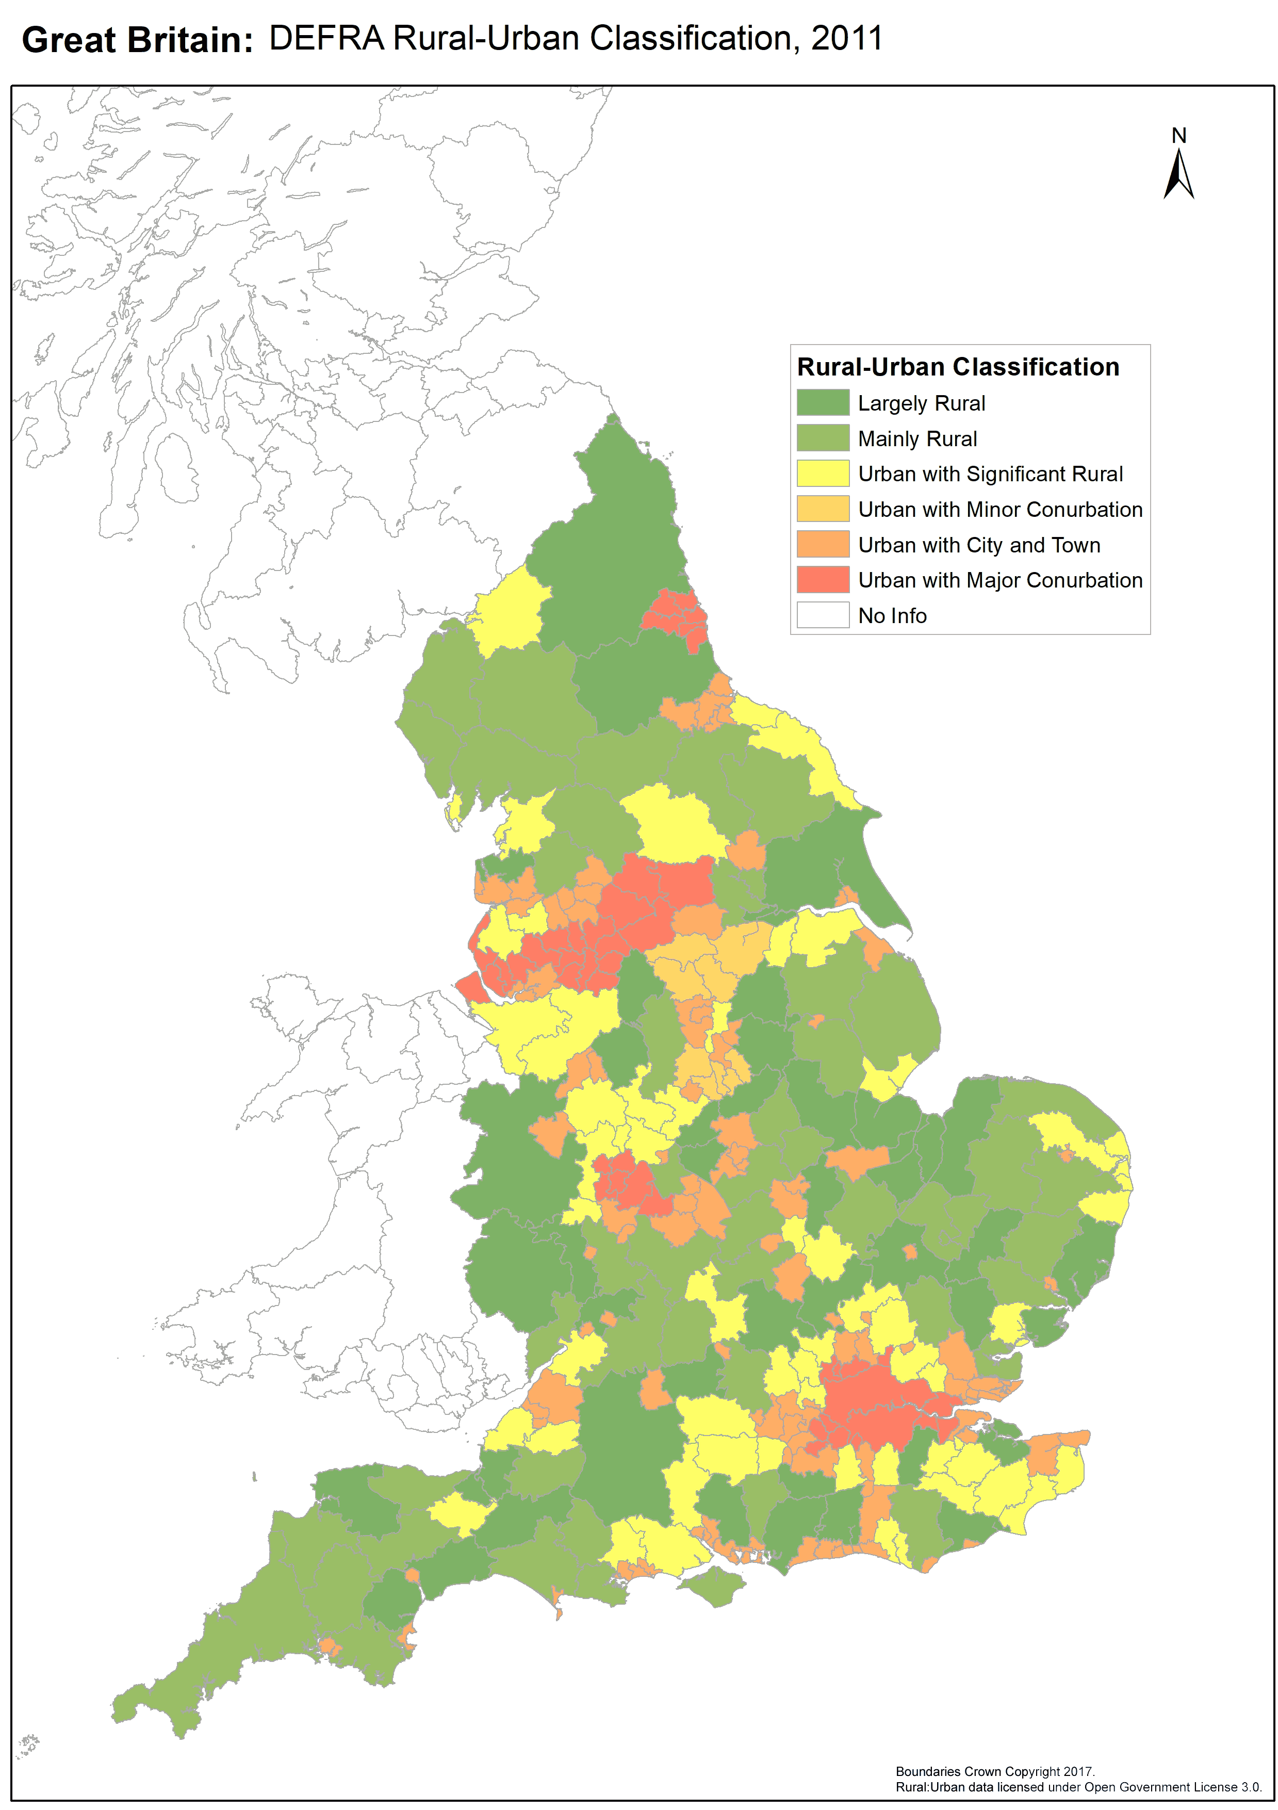

Map 5 – Rural Urban Classification England

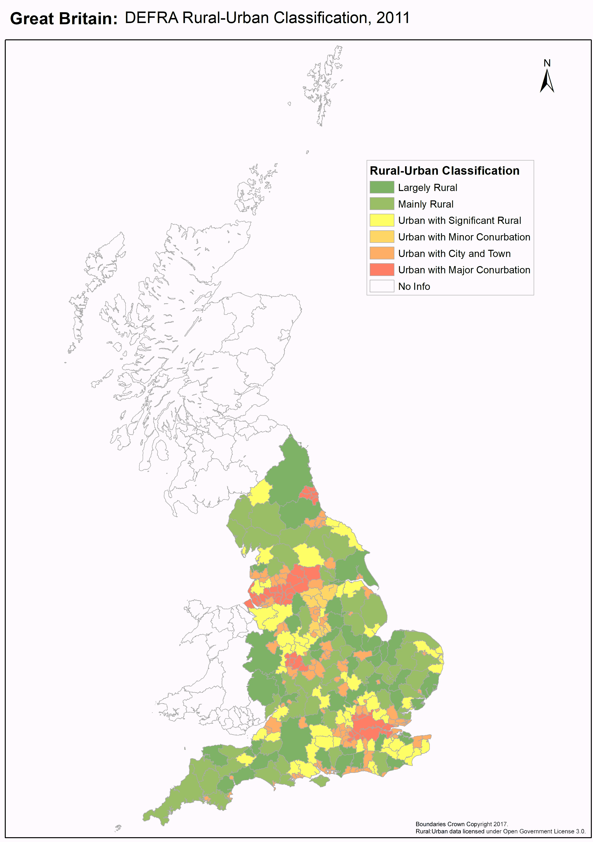

Map 6 – Rural Urban Classification UK

## Appendix 4: Acknowledgements

Dick Fowler provided the information and the prompt that equipped and caused me to undertake this research.

WhatDoTheyKnow.com provided the means to send and track the 370+ Freedom of Information requests sent in this study. (Full disclosure: I am an administrator of WhatDoTheyKnow.)

Freedom of Information Officers and Taxi Licensing Officers up and down the country provided the information on which this study is based, on top of all their other work. I am grateful.

Emma Vogelmann, Trailblazers, Transport for All and other disabled people and their organisations have provided information, campaigned in the area and spurred me on in this research.

John Pring of the Disability News Service covered early results from this study, as did journalists at the One Show and You and Yours.

Fleur Perry assisted with statistical interpretation, and recommended suitable actions and publicity.

The Equality Act 2010 and Disability committee browbeat the Department for Transport into commencing sections 165-167 of the Equality Act in the first place and have expressed an interest in the results of this study.

The Department for Transport, Transport Scotland and the Office for National Statistics published data used in this study.

I am grateful to them all.

## Appendix 5: Licensing

Except for the public-sector information as below, this work “Licensing authorities’ approach to the Equality Act 2010 provisions on taxi wheelchair discrimination” by Doug Paulley is licensed under the Creative Commons Attribution-ShareAlike 4.0 International License. To view a copy of this license, visit http://creativecommons.org/licenses/by-sa/4.0/.

Contains public sector information licensed under the Open Government License v3.0. http://www.nationalarchives.gov.uk/doc/open-government-licence/version/3/

## Appendix 6: Lists of Tables, Figures and Maps

### Tables

Table 1 - S167 grade 8

Table 2 – S167 intent 9

Table 3 – Rural: Urban categorisation 9

Table 4 - GB S167 Intent 12

Table 5 – Constituent countries S167 intent 12

Table 6 – GB S167 grades 14

Table 7 – Constituent countries S167 grades 14

Table 8 – Rural: Urban S167 Intent 16

Table 9 – Rural Urban Classification S167 Intent 16

Table 10 - Wheelchair Accessible Taxis in each area 19

Table 11 – S167 intent of areas with 100% and non-100% accessible taxi fleets 20

Table 12 – Enforcement mechanisms 23

Table 13 – Disability Awareness Training requirements by S167 Grade 25

### Figures

Figure 1 –GB S167 intent 10

Figure 2 – Constituent countries S167 intent 12

Figure 3 – GB S167 grades 13

Figure 4 – Constituent countries S167 grades 14

Figure 5 – Rural Urban Classification S167 Intent 16

Figure 6 – Rural Urban Classification S167 Grade 17

Figure 7 – Wheelchair accessible taxis by Rural Urban Classification 18

Figure 8 – Wheelchair accessible taxis by Rural: Urban 18

Figure 9 –Wheelchair Accessible Taxis in each area 19

Figure 10 – Proportion of Accessible Taxis by S167 Grade 19

Figure 11 – Enforcement mechanisms 23

Figure 12 – GB Authorities with Voluntary Lists 24

Figure 13 – Constituent Countries Voluntary Lists 24

Figure 14 – Disability Awareness Training 25

Figure 15 – Wheelchair Only licenses by S167 Grade 25

### Maps

Map 1 - Map of S167 intent 11

Map 2 – S167 grades 15

Map 3 – Accessible Taxis per 1,000 Population 21

Map 4 – Areas with 0% and 100% wheelchair accessible taxi fleets 22

## Appendix 7: References

1. *Equality Act 2010 c.15*, available at http://www.legislation.gov.uk/ukpga/2010/15 [Accessed: 10 July 2017]
2. Hansard. (2015) *Equality Act 2010 and Disability Select Committee proceedings for Tuesday 15 December 2015*, video available at

   http://parliamentlive.tv/event/index/ae6b6f0c-71fb-4385-889b-5275f94fba81?in=15:59:52

   [Accessed: 10 July 2017]
3. Department for Transport. (2017) *Access for wheelchair users to Taxis and Private Hire Vehicles: Statutory Guidance* [pdf] Available at:

   https://www.gov.uk/government/uploads/system/uploads/attachment_data/file/593350/access-for-wheelchair-users-taxis-and-private-hire-vehicles.pdf [Accessed: 10 July 2017]
4. *The Public Service Vehicles (Conduct of Drivers, Inspectors, Conductors and Passengers) (Amendment) Regulations 2002*. Available at: http://www.legislation.gov.uk/uksi/2002/1724/contents/made [Accessed: 13 July 2017]
5. Department for Transport. (2013) *Response to FOI request: Enforcement of The Public Service Vehicles (Conduct of Drivers, Inspectors, Conductors and Passengers) (Amendment) Regulations 2002.* [pdf]Available at: https://www.whatdotheyknow.com/request/178430/response/462188/attach/3/131217%20L%20F0010739%20IR%20Response.pdf [Accessed: 13 July 2017]
6. Equality Act 2010 and Disability Select Committee (2016): *The Equality Act 2010: the impact on disabled people* Available at: https://www.publications.parliament.uk/pa/ld201516/ldselect/ldeqact/117/11710.htm#_idTextAnchor129 [Accessed: 13July 2017]
7. Department for Transport (2015): *Taxi and private hire vehicles statistics, England: 2015*. Available at: https://www.gov.uk/government/statistics/taxi-and-private-hire-vehicles-statistics-england-2015 [Accessed: 13 July 2017] (Confusingly: includes statistics for licensing in Wales.)
8. Transport Scotland (2017): *Scottish Transport Statistics No 35 – Datasets*. Available at: https://www.transport.gov.scot/publication/scottish-transport-statistics-no-35-datasets/ [Accessed: 13 July 2017]
9. *Freedom of Information Act 2000 c.36 sections 1, 10 and 17*, available at http://www.legislation.gov.uk/ukpga/2000/36/contents [Accessed: 13th July 2017]
10. Department for Environment, Food & Rural Affairs (2011): *Rural-Urban Classification of Local Authority Districts and other higher-level geographies for statistical purposes*. Available at: https://www.gov.uk/government/statistics/2011-rural-urban-classification-of-local-authority-and-other-higher-level-geographies-for-statistical-purposes [Accessed: 13July 2017]
11. Transport for London (2017) *Passengers and Accessibility.* Available at: https://tfl.gov.uk/info-for/taxis-and-private-hire/passengers-and-accessibility?cid=tph-access [Accessed: 14 July 2017]
12. Doug Paulley (2017) *Licensing authorities’ approach to the Equality Act 2010 provisions on taxi wheelchair discrimination*. [.xlsx] Available at: https://www.kingqueen.org.uk/s167 [Accessed: 13 July 2017]
13. Ashford Borough Council (2017) *Response to Freedom of Information Request: Lists of Accessible Taxis under S167 Equality Act 2010* Available at: https://www.whatdotheyknow.com/request/lists_of_accessible_taxis_under_6 [Accessed: 17 July 2017]
14. Andrew Jones MP (2015) *Oral evidence - Equality Act 2010 and Disability - 15 Dec 2015*. Available at: http://data.parliament.uk/writtenevidence/committeeevidence.svc/evidencedocument/equality-act-2010-and-disability-committee/equality-act-2010-and-disability/oral/26351.html. [Accessed: 15 July 2017]
15. Disability News Service (2017) *Setback for taxi wheelchair access, after councils snub new laws.* Available at https://www.disabilitynewsservice.com/setback-for-taxi-wheelchair-access-after-councils-snub-new-laws/ [Accessed: 15 July 2017]
16. Nottingham City Council (2017) *Internal Review of FOI request* *“Lists of Accessible Taxis under S167 Equality Act 2010”* [PDF]Available at https://www.whatdotheyknow.com/request/402029 [Accessed: 15 July 2017]
17. Cambridge City Council (2017) *Internal Review of FOI request: “Lists of Accessible Taxis under S167 Equality Act 2010”* Available at https://www.whatdotheyknow.com/request/lists_of_accessible_taxis_under_41 [Accessed: 15 July 2017]
18. Department for Transport (2017) *Response to Freedom of Information Request: S167 lists and “all our taxis are accessible”* [PDF]. Available at: https://www.whatdotheyknow.com/request/409490/response/1002021/attach/2/170706%20L%20F0014864%20IR%20response.pdf [Accessed: 15 July 2017]
19. Baroness Jane Campbell (2016), quoted in Disability News Service (2016)’s articles *Ministers face twin attack over bus accessibility failures* and *Baroness Campbell vows to fight on over access to buses.* Available at https://www.disabilitynewsservice.com/ministers-face-twin-attack-over-bus-accessibility-failures/ and https://www.disabilitynewsservice.com/baroness-campbell-vows-to-fight-on-over-access-to-buses/ [Accessed: 15th July 2017]
20. United Nations Committee on the Rights of People with Disabilities (2016) *Inquiry concerning the United Kingdom of Great Britain and Northern Ireland carried out by the Committee under article 6 of the Optional Protocol to the Convention: Report to the Committee* [.doc] Available at: http://www.ohchr.org/Documents/HRBodies/CRPD/CRPD.C.15.R.2.Rev.1-ENG.doc [Accessed: 15 July 2017]