April 2018 update: Licensing authorities’ approach to the Equality Act 2010 provisions on taxi wheelchair discrimination

Doug Paulley, April 2018

**https://www.kingqueen.org.uk/s167**

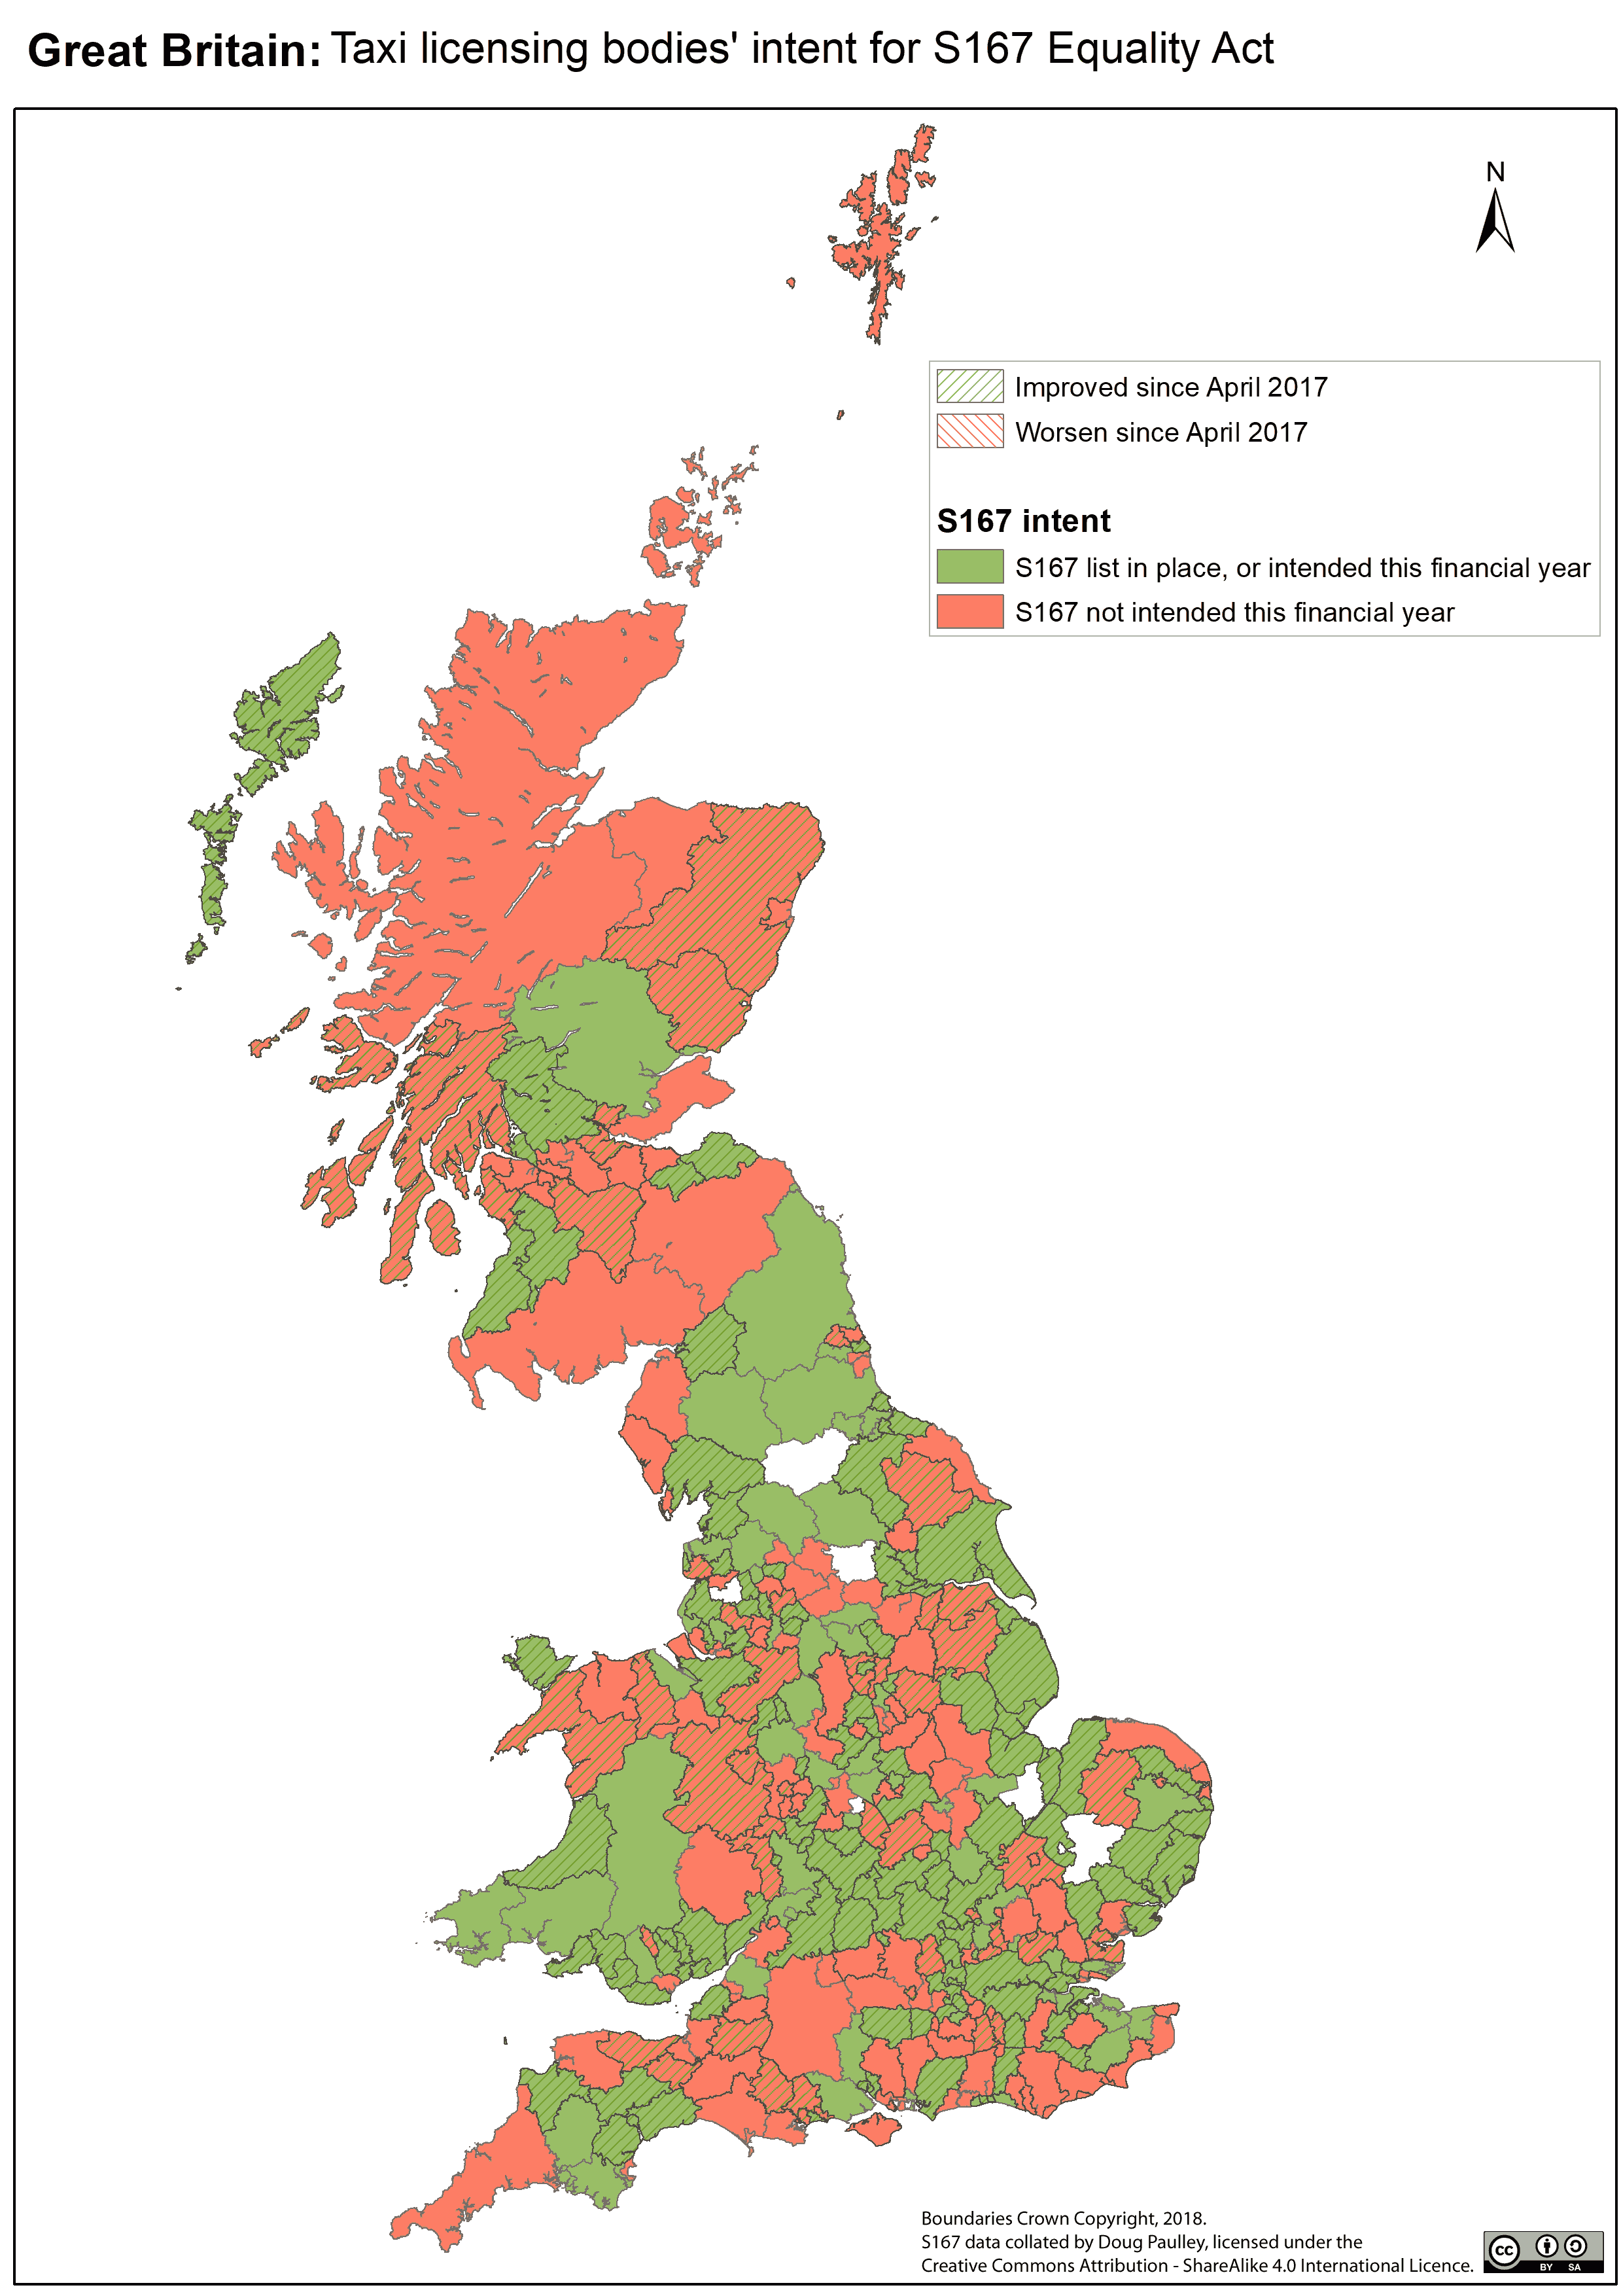

# Abstract

This is follow-up research to my previous report “Licensing authorities’ approach to Section 167 of the Equality Act 2010”. It is intended to examine local authorities’ implementation of S165-S167 in the intervening six months.

Section 165 of the Equality Act 2010 makes it illegal for taxi drivers to discriminate against wheelchair users. It was commenced in April 2017 but only takes effect in areas in which the taxi licensing authority has created a “designated list” of accessible vehicles under S167 of the Act. The Department for Transport’s statutory guidance advises authorities to construct a list, and that authorities should be able to produce these lists by 6th October 2017.

Only 35% of authorities have created a list. Only 51% of authorities have a clear plan to do so by the end of the financial year. Many of those that have created lists have failed to follow the statutory guidance, bringing enforceability into question. There has been no legal action taken against any taxi driver for discriminatory treatment contrary to Section 165.

Coupled with the very variable provision of wheelchair accessible taxis around Great Britain, local authorities’ failure to consistently implement and enforce this legislation constitutes a substantial barrier to disabled people’s transport rights and undermines the intent behind these provisions of the Act.

Contents

1. Abstract 1

3. Introduction 4

a) Legislative background 4

b) The issue in question 4

c) Subsidiary issues 4

Compliance with Statutory Guidance

Exemptions and Applications

Enforcement

Taxi provision statistics

4. Methods 6

a) Freedom of Information (FOI) Requests 6

b) Characteristics of licensing authorities 6

Data for England, Scotland and Wales

Data for England and Wales only

c) Classification of Authorities’ Responses 7

S167 grade

d) Analysis 7

5. Results 8

a) Accompanying spreadsheet 8

b) S167 intent 8

Overall

S167 intent by Country

c) S167 Grade 11

d) Changes in approach to S167 14

e) Authorities with 100% wheelchair accessible fleets 16

f) Compliance with Statutory Guidance 17

g) Driver Guidance 19

h) Medical exemption application procedures 19

i) Lists of vehicles that accommodate wheelchair users who can transfer 19

j) Exemptions under S166 20

k) Changes in Provision of Wheelchair Accessible Vehicles 21

l) Licensing authorities’ Policies on Wheelchair Accessibility 26

m) Enforcement 27

n) Other statutory procedures 27

o) Qualitative observations 27

Lack of knowledge or understanding of S165–S167

Licensing authorities with 100% accessible fleets

“Insufficient” accessible taxis

6. Discussion 29

a) Importance of Taxis 29

b) S167 take-up 29

c) S167 implementation 29

d) Stretch goals 30

Wheelchair transfer lists

“Outsize” wheelchairs

Leaving the meter running

e) Areas with poor provision 31

f) Unclear guidance 31

g) Lack of enforcement 31

h) Failure of the legislation 32

7. Conclusion 33

8. Recommendations 34

a) To the Department for Transport 34

b) To Local Authorities and TFL 34

c) To disabled people, disabled people’s organisations and allies 34

9. Appendices 35

Appendix 1: Sample Freedom of Information request 35

Appendix 2: Acknowledgements 39

Appendix 3: Licensing 39

Appendix 4: Lists of Tables, Figures and Maps 40

Tables

Figures

Maps

Appendix 5: References 41

# Introduction

## Legislative background

This research is to examine whether taxi licensing authorities have changed their intent regarding the powers newly afforded to them because of the commencement of sections 165 and 167 of the Equality Act (the Act) on 6th April 2017. This legislation makes it illegal for taxi and private hire drivers to discriminate against wheelchair users – but only where the authority does the necessary office work.

This report is an update to my similar research report of June 2017, which also looked at authorities’ disposition regarding this legislation.[1]

In February 2017, the Department for Transport issued statutory guidance to taxi licensing authorities[2], which states:

Section 167 of the Act permits, but does not require, LAs (Local Authorities) to maintain a designated list of wheelchair accessible taxis and PHVs.

Whilst LAs are under no specific legal obligation to maintain a list under section 167, the Government recommends strongly that they do so. Without such a list the requirements of section 165 of the Act do not apply, and drivers may continue to refuse the carriage of wheelchair users, fail to provide them with assistance, or to charge them extra.

The guidance recommended authorities work towards producing a S167 list by October 2017.

## The issue in question

My previous report, compiled shortly after S165-S167 were commenced, evaluated whether taxi and PHV licensing authorities intended to use their power to create a S167 list. My intent in this research is to examine any change in actions and attitudes of taxi licensing authorities in the intervening six months.

## Subsidiary issues

### Compliance with Statutory Guidance

The Government’s guidance stated:

Before drivers can be subject to the duties under section 165 of the Act, the LA must first publish their list of designated vehicles, and clearly mark it as ‘designated for the purposes of section 165 of the Act’.

LAs should ensure that their designated lists are made easily available to passengers, and that vehicle owners and drivers are made aware. Lists should set out the details of the make and model of the vehicle, together with specifying whether the vehicle is a taxi or private hire vehicle, and stating the name of operator. Where possible it would also be helpful to include information about the size and weight of wheelchair that can be accommodated, and whether wheelchairs that are larger than a “reference wheelchair” can be accommodated.

Similarly

The Government therefore recommends that a vehicle should only be included in the authority’s list if it would be possible for the user of a “reference wheelchair” to enter, leave and travel in the passenger compartment in safety and reasonable comfort whilst seated in their wheelchair.

Also

We would therefore recommend that LAs also publish a list of vehicles that are accessible to passengers in wheelchairs who are able to transfer from their wheelchair into a seat within the vehicle.

I examined licensing authorities’ compliance with these requirements and recommendations.

### Exemptions and Applications

Drivers of accessible vehicles may apply for medical exemption from the duties not to discriminate against wheelchair users. The DFT recommended:

We suggest that authorities produce application forms which can be submitted by applicants along with evidence supporting their claim. … as an absolute minimum, we think that the evidence provided should be in the form of a letter or report from a general practitioner. … We would recommend that independent medical assessors are used where a long-term exemption is to be issued.

I examined the number of such exemptions granted by authorities, the mechanisms for considering applications for such exemptions and use of the statutory mechanisms for appealing an authority’s refusal to grant a medical exemption.

I also examined use of the statutory provisions to contest an authority’s decision to include a vehicle on the S167 list (i.e. disputing that said vehicle isn’t fully wheelchair accessible.)

### Enforcement

As noted in my previous report, analogous regulations[3] which place bus drivers under obligations to wheelchair users have never been enforced. I have therefore investigated the degree of enforcement in the first six months since commencement of S165 and S167.

### Taxi provision statistics

Since my original report, the Department for Transport has released updated taxi licensing statistics for England and Wales as of March 2017.[4] I examined changes in numbers and proportions of accessible taxis, changes in local authorities’ policies regarding licensing of accessible taxis, and their policies on drivers/ disability awareness training.

# Methods

## a) Freedom of Information (FOI) Requests

On 4th November 2017, I sent Freedom of Information (FOI) request to all 367 licensing authorities. I sent each authority one of six different FOI requests dependent on the authority’s previous approach to S167. (See Appendix 1.) As before, I sent the requests via WhatDoTheyKnow.com, to assist with keeping track of the requests and to ensure that all responses are published online for any interested party to read.

I collated the responses and acted where required to pressurise authorities into providing the information. This involved sending and receiving thousands of emails over several months; chasing, requesting internal reviews and involving the Information Commissioner / Scottish Information Commissioner – who had to act to make 59 authorities respond properly.

As of writing, 340 of the 347 authorities have responded with all the information I requested. The remaining 7 only supplied partial information, even after internal review, and are awaiting the further intervention of the Information Commissioner. The “success rate” of my 367 FOI requests is therefore over 98%.

342 of the 347 authorities (98%) have stated whether they have a current S167 list or intend to create one.

## Characteristics of licensing authorities

I sourced or derived the following data from the datasets released by the Department for Transport in 2015 and 2017, and similar information by Transport Scotland.

### Data for England, Scotland and Wales

* The number of accessible taxis licensed by each authority
* The proportion of taxis licensed by the authority that are wheelchair accessible
* The number of wheelchair accessible taxis per thousand population in the licensing authority’s area

### Data for England and Wales only

* Whether the licensing authority requires some or all licensed taxis to be wheelchair accessible
* Whether the licensing authority obliges taxi drivers to undertake disability awareness training
* Changes since 2015 in the number and proportion of licensed taxis that are wheelchair accessible and in the number of accessible taxis per thousand population, in each licensing authority’s area.

## Classification of Authorities’ Responses

I used the same classification mechanism as in my previous report:

### S167 grade

|  |  |
| --- | --- |
| **A** | **Authority has a valid S167 list in place** |
| **B** | **Authority intends to produce a S167 list this financial year** |
| **C** | **Authority intends to produce S167 list but has no clear deadline** |
| **D** | **Authority is currently undecided whether to produce a S167 list** |
| **E** | **Authority has no current plans to produce a S167 list** |

Table 1 – S167 grade

For further simplification, I also split councils as follows:

**S167 intent**

|  |  |  |
| --- | --- | --- |
| **Yes** | **Authority has a current S167 list, or intends to produce one this financial year**  **(S167 grades A or B)** | |
| **No** | **Authority hasn’t set a date for producing a S167 list, has yet to decide whether to produce one or has no current plans to do so (S167 grades C, D or E)** |  |

Table 2 – S167 intent

## Analysis

I then undertook statistical analysis of the data collected via Freedom of Information requests, together with the data provided by the Department for Transport and by Transport Scotland, to identify common trends and anomalies, and to produce statistics.

# Results

## Accompanying spreadsheet

The data tables, statistical analysis, charts and maps are available in the [accompanying spreadsheet](https://www.kingqueen.org.uk/s167)[5]. This spreadsheet contains data and analysis from my original research report, together with that used in this update.

As the remaining data comes in, I shall update the accompanying spreadsheet, but not this report. For the full and up to date results, data and calculations, please examine the spreadsheet.

## S167 intent

### Overall

Figure 1 –GB S167 intent



Map 1 – S167 intent

|  |  |  |
| --- | --- | --- |
| **S167 intent** | **# Authorities** | **% Authorities** |
| **Yes** | 173 | 51% |
| **No** | 169 | 49% |

Table 3 – GB S167 Intent

|  |  |
| --- | --- |
| **Yes** | **have a S167 list or intend one within this financial year** |
| **No** | **yet to decide / decided not to / not set a date.** |

Just over half of authorities have a S167 list or intend to create one by the end of the financial year.

### S167 intent by Country

Figure 2 – Constituent countries S167 intent

|  |  |  |  |  |  |  |
| --- | --- | --- | --- | --- | --- | --- |
| **S167 intent** | **English Authorities** | **% English Authorities** | **Scottish Authorities** | **% Scottish Authorities** | **Welsh Authorities** | **% Welsh Authorities** |
| Yes | **148** | **51%** | **9** | **28%** | **16** | **73%** |
| No | **140** | **49%** | **23** | **72%** | **6** | **27%** |
| **Total** | **287** | **100%** | **32** | **100%** | **22** | **100%** |

Table 4 – Constituent countries S167 intent

It is apparent that Welsh authorities have a considerably more comprehensive and positive approach to S167 than the rest of Great Britain. Scottish authorities have a distinctly lower rate of intended take up of S167 compared to English authorities.

## S167 Grade

|  |  |  |  |
| --- | --- | --- | --- |
|  |  |  |  |
|  | **LEGEND:** |  |  |
|  |  |  |  |
|  | **A** | **Current S167 list** |  |
|  | **B** | **Producing S167 list this financial year** |  |
|  | **C** | **Producing S167 list but no clear deadline** |  |
|  | **D** | **Undecided whether producing S167 list** |  |
|  | **E** | **No current plans to produce S167 list** |  |
|  |  |  |  |

Figure 3 – GB S167 grade

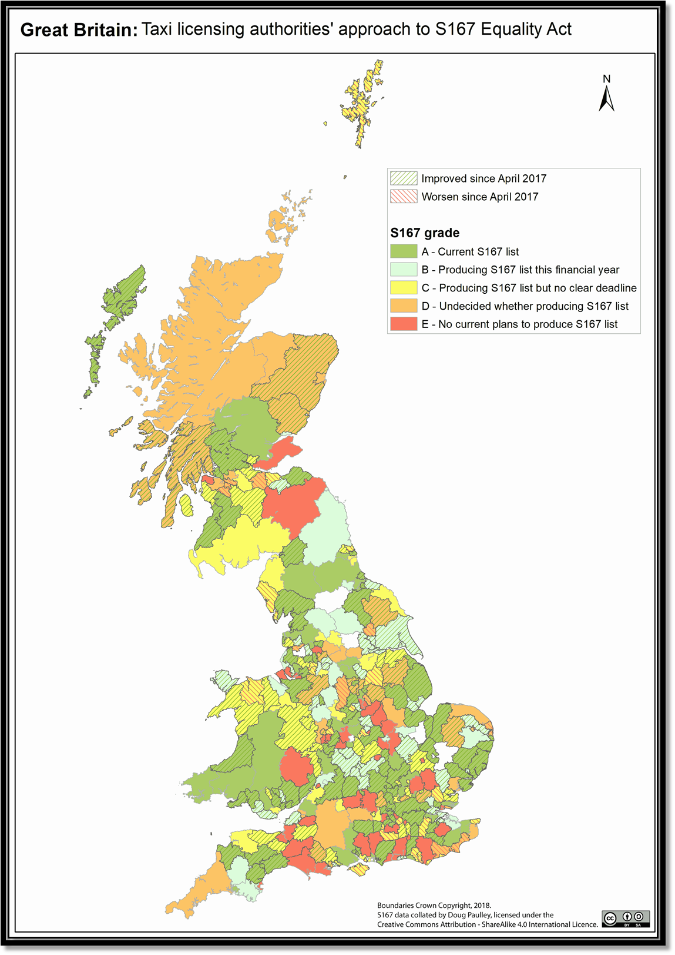

Map 2 – S167 grades

|  |  |  |
| --- | --- | --- |
| **S167 status** | **# Authorities** | **% Authorities** |
| **A** | 119 | 35% |
| **B** | 54 | 16% |
| **C** | 74 | 23% |
| **D** | 49 | 14% |
| **E** | 42 | 12% |
| **Total** | **342** | **100%** |

Table 5 – GB S167 grades

It is perhaps unsurprising that a substantial proportion of authorities intend to create a list this financial year, in accordance with the DFT’s guidance. Of concern are the 18% who have yet to decide whether to create a list, and the 26% who have no current plans to do so.

|  |  |  |  |  |  |  |
| --- | --- | --- | --- | --- | --- | --- |
| **S167 grade** | **English authorities** | **% English authorities** | **Scottish authorities** | **% Scottish authorities** | **Welsh authorities** | **% Welsh authorities** |
| **A** | **101** | **35%** | **7** | **22%** | **11** | **50%** |
| **B** | **47** | **16%** | **2** | **6%** | **5** | **23%** |
| **C** | **64** | **22%** | **8** | **25%** | **6** | **27%** |
| **D** | **37** | **13%** | **12** | **38%** | **0** |  |
| **E** | **39** | **14%** | **3** | **9%** | **0** |  |
| **Total** | **288** | **100%** | **32** | **100%** | **22** | **100%** |

Figure 4 – Constituent countries S167 grades

Table 6 – Constituent countries’ S167 grades

All Welsh authorities either have a S167 list or intend to create one at some point. This is in marked contrast to England, where 28% of authorities have not decided to create a list, and Scotland, where 47% of authorities have not decided to create a list.

It is notable that 38% of Scottish authorities have yet to reach any decision as to whether they will create a list.

## Changes in approach to S167

Figure 5 – Changes in S167 Intent and Grades

|  |  |  |
| --- | --- | --- |
| **∆ S167 intent** | **∆ # Authorities** | **∆ % Authorities** |
| **Yes** | +28 | +9% |
| **No** | -33 | -9% |

|  |  |  |
| --- | --- | --- |
| **∆ S167 grade** | **∆ # Authorities** | **∆ % Authorities** |
| **A** | +80 | +24% |
| **B** | -52 | -15% |
| **C** | +21 | +6% |
| **D** | -14 | -4% |
| **E** | -40 | -11% |

Table 7 – GB Changes in S167 Intent and Grades

There has been a broad shift towards implementation of S167, though implementation of such is still comparatively low.

Figure 6 – Constituent countries’ change in S167 intent and grade

|  |  |  |  |  |  |  |
| --- | --- | --- | --- | --- | --- | --- |
| **∆ S167 intent** | **England** | | **Scotland** | | **Wales** | |
| **#** | **%** | **#** | **%** | **#** | **%** |
| **Yes** | +18 | +7% | +1 | +3% | +9 | +41% |
| **No** | -23 | -7% | -1 | -3% | -9 | -41% |

|  |  |  |  |  |  |  |
| --- | --- | --- | --- | --- | --- | --- |
| **∆ S167 Grade** | **England** | | **Scotland** | | **Wales** | |
| **#** | **%** | **#** | **%** | **#** | **%** |
| **A** | +67 | +23% | +6 | +19% | +7 | +32% |
| **B** | -49 | -16% | -5 | -16% | +2 | +9% |
| **C** | +19 | +7% | +2 | +6% | 0 | 0% |
| **D** | -12 | -4% | +2 | +6% | -4 | -18% |
| **E** | -30 | -10% | -5 | -16% | -5 | -23% |

Table 8 – Constituent countries change in S167 intent and grade

The change in Welsh authorities’ intent regarding S167 lists is notable.

There has been a comparatively small increase in Scottish compliance with S167.

## Authorities with 100% wheelchair accessible fleets

Authorities whose Hackney Carriages are 100% wheelchair accessible have varying approaches to S167 lists.

Figure 7 – S167 intent and grade of authorities with 100% accessible hackney carriage fleets

|  |  |  |
| --- | --- | --- |
| **S167 Status** | **# Authorities** | **% Authorities** |
| **A** | **18** | **27%** |
| **B** | **13** | **20%** |
| **C** | **15** | **23%** |
| **D** | **7** | **11%** |
| **E** | **13** | **20%** |
| **Total** | **66** | **100%** |

|  |  |  |
| --- | --- | --- |
| **S167 intent** | **# Authorities** | **% Authorities** |
| **Yes** | **31** | **47%** |
| **No** | **35** | **53%** |
| **Total** | **66** | **100%** |

Table 9 – S167 intent and grade of authorities with 100% accessible hackney carriage fleets

Fewer authorities with 100% accessible fleets have implemented a S167 list or intend to, compared to authorities without 100% accessible fleets.

## Compliance with Statutory Guidance

|  |  |  |
| --- | --- | --- |
| **LEGEND** | |  |
|  |  |  |
| **Compliant List** | | **S167 list complies with the technical requirements set out in S3.10 of the Department for Transport's Statutory Guidance.** |
| **Ref Wch** | | **S167 list is of vehicles which can accept the standard "reference wheelchair"** |
| **Chair Size** | | **S167 list includes details on what sizes of chair each vehicle can take other than the "reference wheelchair"** |
| **Driver Guidance** | | **Authority has issued drivers of vehicles on the list with guidance as to their legal obligations towards wheelchair users** |
| **Meter Policy** | | **Authority has issued guidance as to when a meter may be left running during loading / unloading a wheelchair user** |
| **Exemption GP Report** | | **Authority accepts GP reports as evidence of drivers' medical inability to comply with obligations to wheelchair users** |
| **Exemption Medical Examiner** | | **Authority has appointed an independent medical examiner to conduct medicals to determine exemptions** |
| **Exemption S166 Form** | | **Authority has a ready-designed form by which drivers can apply for medical exemption** |
| **W/ch Transfer Lists** | | **Authority has a list of vehicles accessible to passengers in wheelchairs able to transfer from their wheelchair into a seat.** |

Figure 8 – Authority compliance with Statutory Guidance

|  |  |  |  |  |  |  |
| --- | --- | --- | --- | --- | --- | --- |
| **Authorities** | **Compliant List #** | **Compliant List %** | **Ref Wch #** | **Ref Wch %** | **Chair Size #** | **Chair Size %** |
| **Yes** | 102 | 82% | 116 | 94% | 10 | 8% |
| **No** | 22 | 18% | 8 | 6% | 114 | 92% |
| **Total** | **124** | **100%** | **124** | **100%** | **124** | **100%** |

Table 10 – Composition of Authorities’ S167 lists

Of the 124 authorities that had produced S167 lists, 22 failed to comply with one or more of the following criteria identified by the statutory guidance as requisite for the list to be valid.

* List is published
* List clearly marked as ‘designated for the purposes of Section 165 of the Act’
* Vehicle owners and drivers made aware their vehicle has been put on the list
* List includes make and model of the vehicle
* List states whether each vehicle is a taxi or private hire
* List records the name of the operator of the vehicle.

Lists that do not comply with these obligations may well be considered not to be valid should any enforcement action be taken against a driver.

Some authorities were confused or unclear as to what a S167 list should comprise. For example, Nottingham City Council stated they have a S167 list, but the Department for Transport disagreed:

The list clearly does not meet the guidance however the guidance does not mandate that LA's publish a list, it simply encourages them to do so. Whether they do so or not is their choice.

If they choose to publish a list for the purposes of meeting S165 of the act, the list must be clearly marked as 'designated for the purposes of section 165 of the Act' – as noted below by the reporter.

3. 9 Before drivers can be subject to the duties under section 165 of the Act, the LA must first publish their list of designated vehicles, and clearly mark it as 'designated for the purposes of section 165 of the Act'.

So in my opinion, I think the key point to note here that the list is not compliant with the guidance but the list is not designated as a list designed to meet S165 and therefore does not need to comply with the guidance, nor are the drivers subject to S165 unless Notts CC decide to designate the list as one for the purposes of meeting 5165. I think there is a remaining question for Notts CC as to whether they intend to designate the list for the purposes of s165 in future and why it hasn't yet been. Unfortunately DfT cannot answer those questions.[6]

Nearly all authorities decided to use ability to accommodate somebody in a “reference wheelchair” as the accessibility standard for a vehicle to be placed on the list.

Very few (8%) had followed the DFT’s stated best practice and included details of the size of wheelchair each taxi can accommodate, including whether the vehicle is suitable for wheelchairs larger than the reference wheelchair.

## Driver Guidance

|  |  |  |  |  |
| --- | --- | --- | --- | --- |
| **Authorities** | **Driver Guidance #** | **Driver Guidance %** | **Meter Policy #** | **Meter Policy %** |
| **Yes** | 99 | 81% | 53 | 43% |
| **No** | 23 | 19% | 71 | 57% |
| **Total** | **122** | **100%** | **124** | **100%** |

Table 11 – Local Authority driver guidance

Most authorities with S167 lists had provided drivers with guidance about their obligations towards wheelchair-using passengers, though a significant proportion (19%) had not. Only 43% of authorities had altered their policy on when meters may be left running (presumably when loading or unloading wheelchair using passengers.)

## Medical exemption application procedures

|  |  |  |  |  |  |  |
| --- | --- | --- | --- | --- | --- | --- |
| **Authorities** | **GP Report #** | **GP Report %** | **Medical Examiner #** | **Medical Examiner %** | **S166 Form #** | **S166 Form %** |
| **Yes** | 287 | 84% | 66 | 19% | 94 | 28% |
| **No** | 53 | 16% | 273 | 81% | 247 | 72% |
| **Total** | **340** | **100%** | **339** | **100%** | **341** | **100%** |

Table 12 – Authority procedures for processing applications for medical exemption

84% of authorities required or accepted a GP report to support a driver’s application for medical exemption from the duty to assist wheelchair users. Only 19% had appointed an external medical examiner to consider such applications, as advised by the DFT guidance. Only 28% of authorities supplied an application form for such exemptions. Most authorities accepted a free text application by letter etc., because they have had very few or no applications for exemption.

## Lists of vehicles that accommodate wheelchair users who can transfer

|  |  |  |
| --- | --- | --- |
| **Authorities** | **Wheelchair Transfer #** | **Wheelchair Transfer %** |
| **Yes** | 9 | 3% |
| **No** | 331 | 97% |
| **Total** | **340** | **100%** |

Table 13 – Authorities that produced lists of vehicles that can accommodate wheelchair users who transfer into a seat

Very few authorities indeed have produced these lists (3%).

It became apparent that the predominant reason for this is that authorities are confused as to what this list would include and what purpose it would serve (as am I.) Some authorities pointed out that all vehicles can accommodate a wheelchair user who can transfer into a seat, provided their wheelchair is capable of being folded and put into the boot.

## Exemptions under S166

|  |  |
| --- | --- |
| **Authorities** | **∆ S166 Exemptions** |
| **Decreased** | **16** |
| **Unchanged** | **276** |
| **Increased** | **47** |
| **Total** | **339** |

Table 14 – Changes in Numbers of S166 Exemptions between April and November 2017

Whilst some authorities have had an increased number of applications for medical exemption from the duties to assist wheelchair users since the legislation was introduced, most are unchanged and some have reduced the number of such exemptions.

266 authorities still have no such exemptions. All but 16 authorities have 10 or less of such exemptions in place.

The notable outlier is Edinburgh, which has 363 such exemptions in place[7] – this is more than four times as many as the council with the next highest number of exemptions (Rushmoor, with 75) and represented an increase of 100 such exemptions since April 2017.

Plymouth also had a significant increase in the number of exemptions, from 4 in April 2017 to 65 in October 2017. Notably, Plymouth implemented a S167 list as soon as the legislation was commenced.

Blackpool and Milton Keynes experienced a significant decrease in the number of exemptions, reducing such by 29 and 17 respectively. Both councils implemented their S167 list between April and October 2018.

## Changes in Provision of Wheelchair Accessible Vehicles

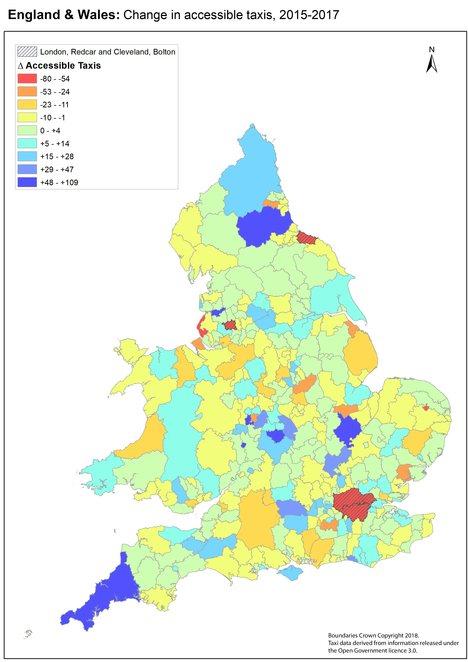

Map 3 – Changes in Accessible Taxi Numbers between 2015 and 2017

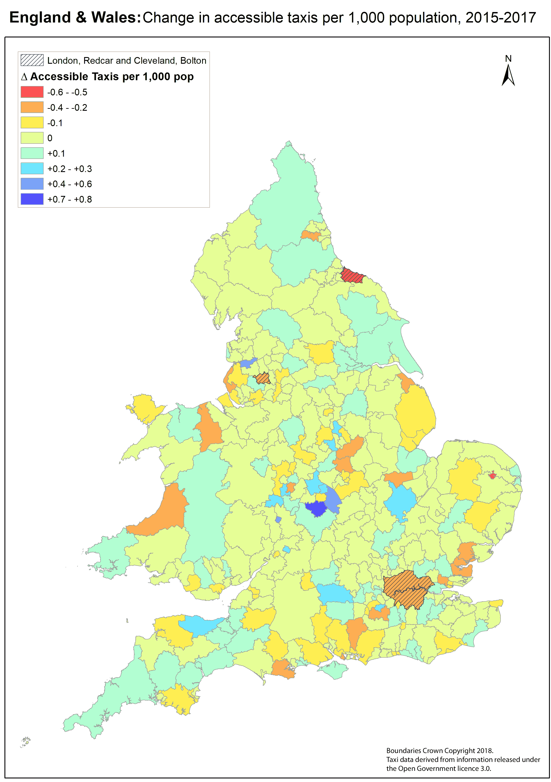

Map 4 – Change in Accessible Taxis per 1,000 population between 2015 and 2017

|  |  |  |  |  |
| --- | --- | --- | --- | --- |
| **Country** | **WAV #** | **WAV % of All Taxis** | **WAV Change since 2015** | **Change in % since 2015** |
| **England** | **43,531** | **58%** | -821 | -2% |
| **England excluding London** | **22,231** | **41%** | +379 | +2% |
| **Wales** | **1,348** | **27%** | +5 | +0% |
| **England + Wales** | **43,531** | **54%** | -816 | -2% |
| **Scotland** | **4,954** | **47%** | n/a | n/a |

|  |  |  |  |  |  |  |
| --- | --- | --- | --- | --- | --- | --- |
| **Country** | **Number Authorities Increased** | **Proportion Authorities Increased** | **Ave Inc WAV # / Authority** | **Number Authorities Decreased** | **Proportion Authorities Decreased** | **Ave Dec WAV # / Authority** |
| **England** | +115 | +40% | **n/a** | -125 | -43% | **n/a** |
| **England excluding London** | n/a | n/a | +5.0 | n/a | n/a | -3.7 |
| **Wales** | +9 | +41% | +3.7 | -11 | -50% | -3.5 |
| **England + Wales** | +124 | +40% | +4.9 | -136 | -43% | -3.7 |
| **Scotland** | n/a | n/a | **n/a** | n/a | n/a | **n/a** |

Table 15 – Changes in wheelchair accessible taxi vehicle numbers, 2015–2017

Overall, there has been a decrease in wheelchair accessible hackney carriages in Great Britain between 2015 and 2017. However, the changes in London skew these results. London has experienced a considerable decline in the number of taxis (1,000 lost in two years). As all London’s taxis are accessible, this represents a substantial proportion of the loss.

If we exclude London, there has been an increase in provision of wheelchair accessible taxis across England and Wales – from 39% of all taxis to 41%, an increase of 379.

That average, however, hides considerable variation in change of provision of accessible vehicles. 40% of authorities increased their provision of licensed wheelchair accessible vehicles between 2015 and 2017; 43% decreased their provision.

9 authorities lost all its existing fleet of wheelchair accessible vehicles. These authorities are Denbighshire (which lost 20), Harborough, Oadby and Wigston, Allerdale, Bolsover, Fenland, South Cambridgeshire, Derbyshire Dales and North East Derbyshire. These join Broadland, Rutland and South Derbyshire who had no accessible taxis in 2015 and still haven’t in 2017.

Other than London, the authority to have lost the largest number of accessible taxis is Redcar and Cleveland, which went from 82 to 4. Conversely, Warwick increased its fleet of accessible vehicles from 47 to 156.

There is still a significant variation in provision of wheelchair accessible taxis round the country, both in absolute terms and per head of population.

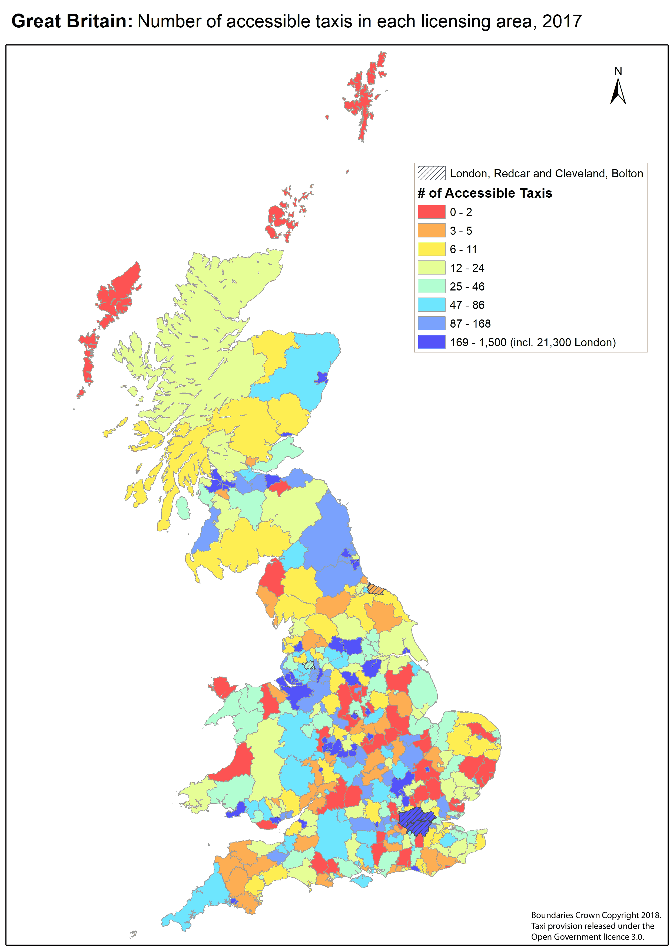

Map 5 – Accessible Taxis in each licensing area, 2017

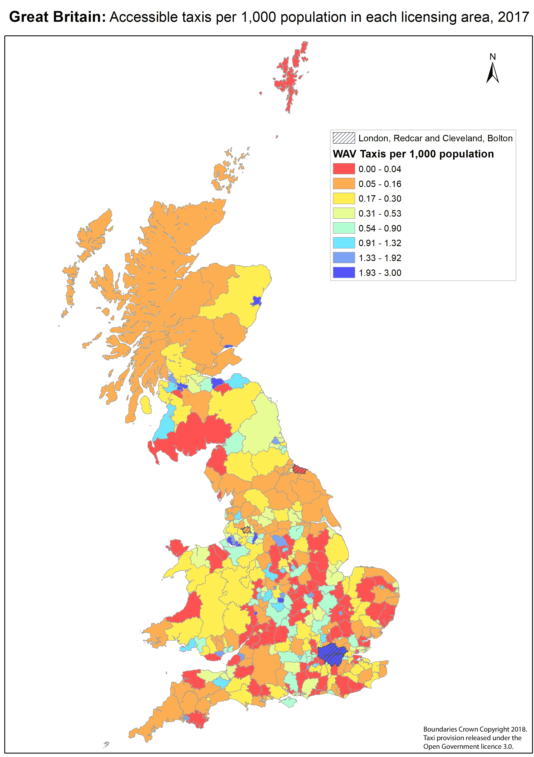

Map 6 – Accessible Taxis per 1,000 population, 2017

## Licensing authorities’ Policies on Wheelchair Accessibility

|  |  |  |  |  |
| --- | --- | --- | --- | --- |
| **Authorities** | **WAV Only #** | **WAV Only %** | **Awareness Training #** | **Awareness Training %** |
| **Yes** | 192 | 61% | 115 | 37% |
| **No** | 121 | 39% | 198 | 63% |
| **Total** | **313** | **100%** | **313** | **100%** |

Table 16 – Licensing authorities’ policy on WAV Only licenses and Awareness Training

Less than two thirds of licensing authorities require some or all licensed taxis to be wheelchair accessible. Just over a third require taxi drivers to undergo disability awareness training.

|  |  |  |  |
| --- | --- | --- | --- |
| **WAV only** | **2015** | **2017** | **Change** |
| **Yes** | 185 | 192 | 7 |
| **No** | 130 | 121 |  |
| **Total** | **315** | **313** |  |

|  |  |  |  |
| --- | --- | --- | --- |
| **Training** | **2015** | **2017** | **Change** |
| **Yes** | 103 | 115 | 12 |
| **No** | 212 | 198 |  |
| **Total** | **315** | **313** |  |

Table 17 – Change in Policy on reserving licenses for WAV and requiring disability awareness training

This shows a slight improvement in taxi access policies over the last two years: overall, an extra 7 authorities reserve licenses for wheelchair accessible vehicles and an extra 12 authorities require drivers to undergo disability awareness training. However, the actual picture is more complex.

|  |  |  |
| --- | --- | --- |
| **# Authorities** | **WAV Only** | **Training** |
| **Implemented** | 17 | 30 |
| **Removed** | 10 | 18 |
| **Unchanged** | 286 | 265 |
| **Total** | **313** | **313** |

Table 18 – GB Licensing authority policy movements on disability accessibility, 2015–2017

10 authorities which previously reserved some or all taxi licenses for wheelchair accessible vehicles have now removed that restriction. Similarly, 18 authorities which previously required taxi drivers undergo disability awareness training have now removed that stipulation.

## Enforcement

**No authority has taken enforcement action against a driver under S165. No authority is aware of any other body or person taking legal action against a driver.**

Transport for London are the only body which indicated any currently pending action against a driver:

Since Section 165 of the Equality Act (2010) was enacted, in April 2017, we have launched 19 investigations. Of these, nine are being actively investigated, one of which has been referred to our legal team for prosecution. The remaining ten investigations have been closed due to insufficient evidence, the complainant not wanting to pursue their original compliant or the driver having been found not to have committed an offence.[8]

## Other statutory procedures

Section 172 allows for appeal of a licensing authority’s decision to include a vehicle on any local authority’s S167 list, and to appeal against a local authority’s decision not to approve a driver’s application for medical exemption from the duty to assist wheelchair users.

There have not been any such appeals at all, in any licensing authority’s area.

## Qualitative observations

Certain aspects of authorities’ approaches to S167 became clear through the Freedom of Information process but were not captured in the above analysis.

### Lack of knowledge or understanding of S165–S167

Overall, there has been an increase in awareness and understanding amongst licensing authorities of sections 165–167 of the Act. However, there is still a distinct problem amongst many local authorities, who still do not understand the purpose of the Act or how to go about implementing it.

**Examples include:**

**Nottingham** City Council, who vacillated several times between stating that they have no intention to create a list, that they have a list (though the Department for Transport stated that the list is not valid) and that they intend to create a list.

**Lewes** Council is similar. Having stated in response to my previous research that they had implemented S167, on further pressing it transpired that they don’t have a S167 list and never have.

**Leeds** City Council believe that the ability to filter their taxi license register by wheelchair accessibility constitutes implementation of S167.

**Tonbridge and Malling** council have let each vehicle owner decide whether their vehicle is listed or not, thus effectively facilitating drivers’ choice whether to be subject to the anti-discrimination legislation.

Despite the Department for Transport’s circulars, my previous research and my clear statement of the statutory guidance, I still had to force some authorities to understand what a Section 167 list is, to obtain a genuine response to my FOI request.

### Licensing authorities with 100% accessible fleets

Fewer of these authorities are implementing S167 than authorities without 100% accessible fleets. For some authorities, this is because they are still unclear that the purpose of a S167 list is to put drivers under a legal obligation not to discriminate and not to provide information for disabled people to travel. Others are content with their existing enforcement mechanisms in their licensing policies.

### “Insufficient” accessible taxis

It is still the case that many authorities have so few accessible taxis that they believe there is “no point” in producing a S167 list. Others produced lists with no vehicles on, because there are no accessible taxis in their area.

**South Bucks** District Council’s S167 list consists of no hackney carriages and three private hire vehicles, together with a note that all three are not available to the public as they are “currently carrying out contract work only”.[9]

# Discussion

## Importance of Taxis

The availability of wheelchair accessible taxis and private hire vehicles remains of key importance to wheelchair users. I quote again Andrew Jones MP (previous Parliamentary Under Secretary of State at the Department for Transport):

I fully recognise that taxis, private hire vehicles and buses are of fundamental importance for disabled people. There is no question about that.[10]

## S167 take-up

There has been an increase in the number of authorities taking up S167, and in authorities with plans to do so.

Even with this increase, authorities who have implemented S167 are still in the minority. This is despite the Department for Transport’s recommendation that most authorities should be able to implement S167 by October 2017, and the DFT’s reminders to authorities on their recommendation to implement this legislation, by emails of 1st August and 5th October 2017.[11]

Only a third of authorities have implemented the legislation, and only half intend to do so by the end of the financial year.

There is a notable variation between the constituent countries. Welsh authorities have a considerably better take-up of S167 than English ones. The Welsh Government has failed to respond to my Freedom of Information request enquiring why “their” councils’ compliance is so notably better. Scottish authorities in the main remain notably undecided or negative concerning implementation of this legislation.

To re-iterate the Department for Transport:

Whilst LAs are under no specific legal obligation to maintain a list under section 167, the Government recommends strongly that they do so. Without such a list the requirements of section 165 of the Act do not apply, and drivers may continue to refuse the carriage of wheelchair users, fail to provide them with assistance, or to charge them extra.

Authorities’ failure to implement S167 of the Equality Act does wheelchair users a profound disservice.

## S167 implementation

Of those authorities which have implemented S167, 18% (22 authorities) have failed to follow the statutory guidelines and thus risk their list being declared non-compliant if enforcement action is taken against a driver. The DfT’s handling of Nottingham council make this risk apparent. It is a shame that authorities have not expended the modest extra effort required to make their list valid under the Act.

## Stretch goals

It is unsurprising that so few licensing authorities have met the good practice extra recommendations set in the DFT statutory guidance, given that only a third of authorities have even gone so far as to implement S167 of the Act.

### Wheelchair transfer lists

One of the good practice extra recommendations was quite simply not capable of being comprehended by licensing authorities, the trade or disabled passengers. It is not viable or sensible to create a list of vehicles into which a wheelchair user can

transfer from their wheelchair into the vehicle and stow their wheelchair in the boot

Multiple authorities pointed out that every vehicle (HCV or PHV) has this facility. Is this list meant to exclude minibuses? Or “black cabs”? Or something else? It is entirely unclear, and its presence in the guidance devalues the remainder.

### “Outsize” wheelchairs

However, other good practice recommendations in the guidance are important and would make a major difference to disabled people if implemented. For example, the suggestion:

it would also be helpful to include information about the size and weight of wheelchair that can be accommodated, and whether wheelchairs that are larger than a “reference wheelchair” can be accommodated.

This:

aims to ensure that users of larger wheelchairs have sufficient information about the vehicles that will be available to them to make informed choices about their journeys.

This is important. I know multiple wheelchair users whose wheelchairs are bigger than the 120x70cm footprint of the “reference wheelchair”, or over 135cm height. They need and deserve effective information to enable them to travel by taxi just as much as any other person. Yet only 10 of the 124 licensing authorities with S167 lists state on their lists what size of wheelchair each vehicle can take; thus leaving wheelchair users to fend for themselves for such information. This does such wheelchair users a great disservice.

### Leaving the meter running

The guidance recommends:

licensing authority rules for drivers are updated to make clear when a meter can and cannot be left running.

This is the primary mechanism for determining if a driver has overcharged a wheelchair user, in contravention of the Act. It is therefore important that this is implemented – yet only 43% of authorities with S167 lists have done so.

## Areas with poor provision

There remain many “no–go” regions of Great Britain that have no usable provision of wheelchair accessible taxis. There has been no systemic increase in provision of accessible taxis over the last two years. There is no evidence of any significant increase in licensing authorities’ actions to remedy this situation. Most licensing authorities are not using the statutory powers available to them to improve taxi provision for wheelchair users.

Many do not use their powers to limit a proportion of licenses to wheelchair accessible vehicles, to require drivers undergo disability awareness training or to implement the S165 discrimination legislation.

Many authorities are actively “going backwards” – they previously had such policies but have rescinded them. Some are evidently antipathetic to implementing the powers given to them by the legislation.

The availability of accessible taxi provision to disabled people is very variable across the country. One may assume that wheelchair users’ experience of taxi provision varies similarly.

## Unclear guidance

My recent research still gives no indication that the Department for Transport has addressed its failure to provide guidance to authorities with 100% wheelchair accessible taxi fleets as to what they need to take to make taxi licensees subject to the new anti-discrimination duties. This fundamental failure means that over half of the 28 authorities who only license accessible taxis have no current intent to create valid S167 lists. Taxi drivers in these areas can discriminate against wheelchair users with impunity.

Authorities’ bemusement at the Department for Transport’s recommendation that “LAs also publish a list of vehicles that are accessible to passengers in wheelchairs who are able to transfer from their wheelchair into a seat within the vehicle” was universal. This resulted in few authorities complying with this recommendation.

It is my opinion that inclusion of this recommendation in the statutory guidance made the guidance less credible and likely affected some authorities’ approach to the legislation.

## Lack of enforcement

There are 30,298 wheelchair accessible hackney carriages licensed by the 119 authorities that have implemented S167 of the Act. Yet there has been no enforcement action taken against any driver.

It is not credible to believe that since this legislation was implemented, none of the drivers of any of those taxis have refused a wheelchair user travel, failed to strap the wheelchair user or their wheelchair in properly, left the meter running whilst loading a wheelchair user or failed to assist the wheelchair user into or out of their taxi. I have personally experienced discrimination in these terms, by drivers of vehicles on a s167 list.

One therefore must wonder why there have been no cases brought under this legislation.

Legislation without enforcement is only guidance; and as I stated in my previous report, guidance hasn’t resulted in the full, guaranteed access that disabled people need and deserve.

## Failure of the legislation

Licensing authorities’ lack of implementation and enforcement of sections 165–167 of the Equality Act leads me to the conclusion that this legislation has failed to provide its intended result: prevention and punishment of taxi drivers’ discrimination against wheelchair users.

Guidance, exhortations and recommendations from the Department for Transport and other bodies have not resulted in significant improvements in implementation and enforcement of this legislation. There is no evidence that such is likely to have an effect in the future.

The implementation and enforcement of this legislation is so lamentably poor, with no sign of improvement, that it is likely that it can only be remedied by new primary legislation.

# Conclusion

In the main, taxi licensing authorities are still not engaging with their power to outlaw taxi drivers’ discrimination against wheelchair users. Even where the legislation has been implemented, licensing authorities have not taken any enforcement action.

The failure of local authorities to implement and enforce the taxi anti-discrimination provisions in the Equality Act renders the legislation ineffective and undermines the purpose for which it was introduced.

As a result, the recent commencement of sections 165 and 167 of the Equality Act will have no effect on disabled people’s experiences in most areas of the UK.

Inconsistent approaches to provision of wheelchair accessible taxis means that poor availability of such vehicles in many areas has not improved over the last two years.

Primary legislation is required to remedy these failures.

# Recommendations

These remain unchanged from my previous report.

## To the Department for Transport

* Update the S167 Statutory Guidance to make clear to licensing authorities with 100% accessible taxi fleets, what actions the authority needs to take to implement S165 and S167 in their area
* Create and disseminate model definitions of wheelchair accessible vehicles, and model enforcement policies and procedures
* Raise the profile of the guidance such that local authorities pay it “due regard”

## To Local Authorities and TFL

* Implement a s167 list for taxis and private hire vehicles in your area
* Do so even if all taxis licensed by yourselves are accessible, or if you have very few accessible taxis
* Consider whether the provision of accessible taxis in your area is adequate for disabled people’s needs, including whether most or all accessible taxis and PHVs are used for statutory bodies’ contracts. If there are insufficient wheelchair accessible taxis available for the general population’s needs, act to increase provision
* Develop and implement proactive enforcement policies and procedures to ensure taxi drivers comply with their obligations towards wheelchair users

## To disabled people, disabled people’s organisations and allies

(including me!)

* Continue campaigning to raise the profile of the inadequacy of this law
* Educate taxi licensing authorities in your area about sections 165 and 167 of the Act
* Pressurise your licensing authorities to create a S167 list and to enforce drivers’ compliance with S165
* Raise the profile of this issue such that a backbencher MP may consider bringing restorative primary legislation by means of a private members’ bill

# Appendices

## Appendix 1: Sample Freedom of Information request

Dear (authority),

I am writing this Freedom of Information Request in relation to your Council's compliance or otherwise with the Government's statutory guidance on implementation of S165–167 of the Equality Act, relating to taxi services for wheelchair users. All taxi licensing bodies are obliged under S167(6) to have "*due regard*" to the document "*Access for wheelchair users to taxis and private hire vehicles: statutory guidance*" at https://www.gov.uk/government/uploads/system/uploads/attachment_data/file/593350/access-for-wheelchair-users-taxis-and-private-hire-vehicles.pdf. The questions I raise below should be interpreted as requests for recorded information under the Freedom of Information Act.

I have previously made a similar request to you in April 2017. 6+ months later, I am repeating the request with some variations. I am repeating because the Statutory Guidance states "*We would expect these arrangements to take no more than a maximum of six months to put in place, following the commencement of these provisions*" – "*these provisions*" having been commenced on 6th April.

In response to my previous FOI request on similar matters in April 2017, you indicated that you did not have a Section 167 list but were intending to create such a list in the relatively imminent future.

1) The Government guidance states: "*Whilst LAs are under no specific legal obligation to maintain a list under section 167, the Government recommends strongly that they do so. Without such a list the requirements of section 165 of the Act do not apply, and drivers may continue to refuse the carriage of wheelchair users, fail to provide them with assistance, or to charge them extra.*"

Please can you indicate whether you do now have a list of wheelchair accessible taxis under your powers set out in Section 167 of the Equality Act 2010, and/or a list of wheelchair accessible private hire vehicles?

2) If you do now have such a list, please provide information in response to the following questions 2a) to 2j):

2a) On what date was it put in place?

2b) The statutory guidance states "*The Government therefore recommends that a vehicle should only be included in the authority’s (S167) list if it would be possible for the user of a “reference wheelchair” to enter, leave and travel in the passenger compartment in safety and reasonable comfort whilst seated in their wheelchair.*"

Is this the definition you have used for a taxi or PHV to be considered wheelchair accessible for the purposes of the list?

2c) The statutory guidance states: "*Before drivers can be subject to the duties under section 165 of the Act, the LA must first publish their list of designated vehicles, and clearly mark it as ‘designated for the purposes of section 165 of the Act’. LAs should ensure that their designated lists are made easily available to passengers, and that vehicle owners and drivers are made aware. Lists should set out the details of the make and model of the vehicle, together with specifying whether the vehicle is a taxi or private hire vehicle, and stating the name of operator.*"

Have you published your list? Is it marked "*designated for the purposes of Section 165 of the Act*"? Is the make and model of each vehicle listed? Is each vehicle identified as a taxi or a private hire vehicle? Is the name of the operator of each vehicle given in the list? Have you made owners and drivers of vehicles on the list aware that their vehicle has been listed?

2d) The guidance states: "*it would also be helpful to include information about the size and weight of wheelchair that can be accommodated, and whether wheelchairs that are larger than a “reference wheelchair” can be accommodated.*"

Does your list include information on each vehicle as to the size and weight of wheelchair that can be accommodated, and whether wheelchairs larger than a "*reference wheelchair*" can be accommodated?

2e) The guidance states: "*We encourage LAs to provide drivers of taxis and PHVs who are not exempt from the duties with clear guidance on their duties with respect to the carriage of passengers in wheelchairs, either as part of existing driver-facing guidance, or as supplementary communication.*"

Have you provided non-exempt taxi/PHV drivers with such guidance?

2f) The guidance states: "*We recommend that licensing authority rules for drivers are updated to make clear when a meter can and cannot be left running*".

Have you updated such rules to make this clear?

2g) The guidance states: "*Section 172 of the Act enables vehicle owners to appeal against the decision of a LA to include their vehicles on the designated list. That appeal should be made to the Magistrate’s Court, or in Scotland the sheriff, and must be made within 28 days of the vehicle in question being included on the LA’s published list.*"

Please tell me how many such applications have been made to the Magistrates Court, and how many have been successful.

2h) How many drivers has the authority prosecuted for discriminatory behaviour contrary to S165 of the Act? How many such prosecutions were successful? What were the sentences?

2i) How many drivers licensed by yourselves have been prosecuted by other people or bodies for failure to comply with S165 of the Act? How many such prosecutions were successful? What were the sentences?

2j) Where drivers have been prosecuted under S165 of the Act, thus affecting their standing as a "fit and proper person", what resultant disciplinary action have you taken in respect of their taxi or private hire vehicle drivers' licenses?

3) If you do not have a S167 list or lists now, please indicate if you still intend to produce such a list.

4) If you don't have a S167 list but do intend to produce one, please provide information in response to questions 4a) and 4b) below.

4a) Please indicate when you intend to have the list in place.

4b) Where you have already made relevant decisions, please indicate whether you intend to comply with the elements of the statutory guidance set out in 2b) to 2f) above.

5) Irrespective of whether you have created a list or not or indeed whether you intend to create such a list, since 2010 you have been obliged to process applications under Section 166 of the Equality Act for driver medical exemptions from the duty to transport and not discriminate against wheelchair users. The Guidance states; "*the Act allows LAs to grant exemptions from the duties to individual drivers. These provisions are contained in section 166, and were commenced on 1st October 2010.*"

5a) How many exemptions have you granted under S166 of the Equality Act 2010?

5b) The guidance states: "*We understand that some licensing authorities have already put in place procedures for accessing and exempting drivers, and as an absolute minimum, we think that the evidence provided should be in the form of a letter or report from a general practitioner.*"

Do you accept or require a letter or report from a GP to process applications for driver exemption under S166?

5c) The guidance states: "*The Government’s view is that decisions on exemptions will be fairer and more objective if medical assessments are undertaken by professionals who have been specifically trained and who are independent of the applicant. We would recommend that independent medical assessors are used where a long-term exemption is to be issued, and that LAs use assessors who hold appropriate professional qualifications and who are not open to bias because of a personal or commercial connection to the applicant*"

Have you appointed independent medical assessors to determine applications for medical exemption under S166?

5d) Please provide a copy of your application form for driver exemption under S166.

5e) The guidance states: "*Section 172 of the Act enables drivers to appeal against the decision of a LA not to issue an exemption certificate. That appeal should be made to the Magistrate’s Court, or a sheriff in Scotland, and must be made within 28 days beginning with the date of the refusal.*"

How many appeals against refusal to issue S166 exemptions have been heard?

5f) How many appeals against refusal to issue S166 exemptions were successful?

6) The guidance states: "*We would therefore recommend that LAs also publish a list of vehicles that are accessible to passengers in wheelchairs who are able to transfer from their wheelchair into a seat within the vehicle. It should be made clear however that this list of vehicles has not been published for the purposes of section 165 of the Act and drivers of those vehicles are therefore not subject to the legal duties to provide assistance.*"

Do you currently publish a list of vehicles that are accessible to passengers in wheelchairs who are able to transfer from their wheelchairs into a seat within the vehicle?

Thank you

Yours faithfully,

Doug Paulley

## Appendix 2: Acknowledgements

Dick Fowler provided the information and the prompt that equipped and caused me to undertake this research.

Andrew Mickel from MDUK / Trailblazers did much to publicise my initial report. He has been invaluable to disabled people and to me.

WhatDoTheyKnow.com provided the means to send and track the 370+ Freedom of Information requests sent in this study. (Full disclosure: I am an administrator of WhatDoTheyKnow.)

Freedom of Information Officers and Taxi Licensing Officers up and down the country provided the information on which this study is based, on top of all their other work. I am grateful.

Disabled people and their organisations have provided information, campaigned in the area and spurred me on in this research.

The Department for Transport, Transport Scotland and the Office for National Statistics published data used in this study.

I am grateful to them all.

## Appendix 3: Licensing

Except for the public-sector information as below, this work “April 2018 update – Licensing authorities’ approach to the Equality Act 2010 provisions on taxi wheelchair discrimination” by Doug Paulley is licensed under the Creative Commons Attribution-ShareAlike 4.0 International License. To view a copy of this license, visit http://creativecommons.org/licenses/by-sa/4.0/.

Contains public sector information licensed under the Open Government License v3.0. http://www.nationalarchives.gov.uk/doc/open-government-licence/version/3/

## Appendix 4: Lists of Tables, Figures and Maps

### Tables

Table 1 – S167 grade 7

Table 2 – S167 intent 7

Table 3 – GB S167 Intent 10

Table 4 – Constituent countries S167 intent 10

Table 5 – GB S167 grades 13

Table 6 – Constituent countries’ S167 grades 13

Table 7 – GB Changes in S167 Intent and Grades 14

Table 8 – Constituent countries change in S167 intent and grade 16

Table 9 – S167 intent and grade of authorities with 100% accessible hackney carriage fleets 16

Table 10 – Composition of Authorities’ S167 lists 18

Table 11 – Local Authority driver guidance 19

Table 12 – Authority procedures for processing applications for medical exemption 19

Table 13 – Authorities that produced lists of vehicles that can accommodate wheelchair users who transfer into a seat 19

Table 14 – Changes in Numbers of S166 Exemptions between April and November 2017 20

Table 15 – Changes in wheelchair accessible taxi vehicle numbers, 2015–2017 23

Table 16 – Licensing authorities’ policy on WAV Only licenses and Awareness Training 26

Table 17 – Change in Policy on reserving licenses for WAV and requiring disability awareness training 26

Table 18 – GB Licensing authority policy movements on disability accessibility, 2015–2017 26

### Figures

Figure 1 –GB S167 intent 8

Figure 2 – Constituent countries S167 intent 10

Figure 3 – GB S167 grade 11

Figure 4 – Constituent countries S167 grades 13

Figure 5 – Changes in S167 Intent and Grades 14

Figure 6 – Constituent countries’ change in S167 intent and grade 15

Figure 7 – S167 intent and grade of authorities with 100% accessible hackney carriage fleets 16

Figure 8 – Authority compliance with Statutory Guidance 17

### Maps

Map 1 – S167 intent 9

Map 2 – S167 grades 12

Map 3 – Changes in Accessible Taxi Numbers between 2015 and 2017 21

Map 4 – Change in Accessible Taxis per 1,000 population between 2015 and 2017 22

Map 5 – Accessible Taxis in each licensing area, 2017 24

Map 6 – Accessible Taxis per 1,000 population, 2017 25

## Appendix 5: References

1. Doug Paulley. (2017) *Licensing authorities’ approach to the Equality Act 2010 provisions on taxi wheelchair discrimination* [pdf} Available at https://www.kingqueen.org.uk/wp-content/uploads/2017/08/Licensing-authorities%E2%80%99-approach-to-the-Equality-Act-2010-provisions-on-taxi-wheelchair-discrimination.pdf [Accessed: 24 January 2018]
2. Department for Transport. (2017) *Access for wheelchair users to Taxis and Private Hire Vehicles: Statutory Guidance* [pdf] Available at:

   https://www.gov.uk/government/uploads/system/uploads/attachment_data/file/593350/access-for-wheelchair-users-taxis-and-private-hire-vehicles.pdf [Accessed: 24 January 2018]
3. *The Public Service Vehicles (Conduct of Drivers, Inspectors, Conductors and Passengers) (Amendment) Regulations 2002*. Available at: http://www.legislation.gov.uk/uksi/2002/1724/contents/made [Accessed: 13 July 2017]
4. Department for Transport (2017): *Taxi and private hire vehicles statistics, England and Wales: 2017*.Available at: https://www.gov.uk/government/statistics/taxi-and-private-hire-vehicles-statistics-england-2017 [Accessed: 22nd January 2018]
5. Doug Paulley (2017) *Licensing authorities’ approach to the Equality Act 2010 provisions on taxi wheelchair discrimination*. [.xlsx] Available at: https://www.kingqueen.org.uk/s167 [Accessed: 13 July 2017]
6. Department for Transport (2018) *Response to Freedom of Information Request: Nottingham's "S167 list" of taxis”* Available at: https://www.whatdotheyknow.com/request/nottinghams_s167_list_of_taxis [Accessed: 11 March 2018]
7. City of Edinburgh Council (2017): *Response to Freedom of Information Request: Lists of Accessible Taxis under S167 Equality Act 2010* Available at: https://www.whatdotheyknow.com/request/s167_list_of_accessible_taxis_up_220 [Accessed 11th March 2018]
8. Transport for London (2017): *Response to Freedom of Information Request* *List of Accessible Taxis: update after 6 months - existing list* Available at: https://www.whatdotheyknow.com/request/s167_list_of_accessible_taxis_up_60 [Accessed 11th March 2018]
9. South Bucks District Council (2017): *List of vehicles designated under section 167 of the Equality Act 2010* Available at: http://www.southbucks.gov.uk/media/11425/Wheelchair-Accessible-Vehicles-List/pdf/South_Bucks_District_Council_Wheelchair_Accessible_Vehicles.pdf [Accessed 11th March 2018]
10. Andrew Jones MP (2015) *Oral evidence - Equality Act 2010 and Disability - 15 Dec 2015*. Available at: http://data.parliament.uk/writtenevidence/committeeevidence.svc/evidencedocument/equality-act-2010-and-disability-committee/equality-act-2010-and-disability/oral/26351.html. [Accessed: 15 July 2017]
11. Department for Transport (2017): *Emails subject “Access to taxis/PHVs to wheelchair users: S165 exemption notices”*. Available at https://www.whatdotheyknow.com/request/nottinghams_s167_list_of_taxis Annex 5 and 6. [Accessed: 12th March 2018.]